

Wealth Tracking Framework

Project Engineering

Year 4

Aaron McKinley

Bachelor of Engineering (Honours) in Software and Electronic Engineering

Atlantic Technological University

2024/2025

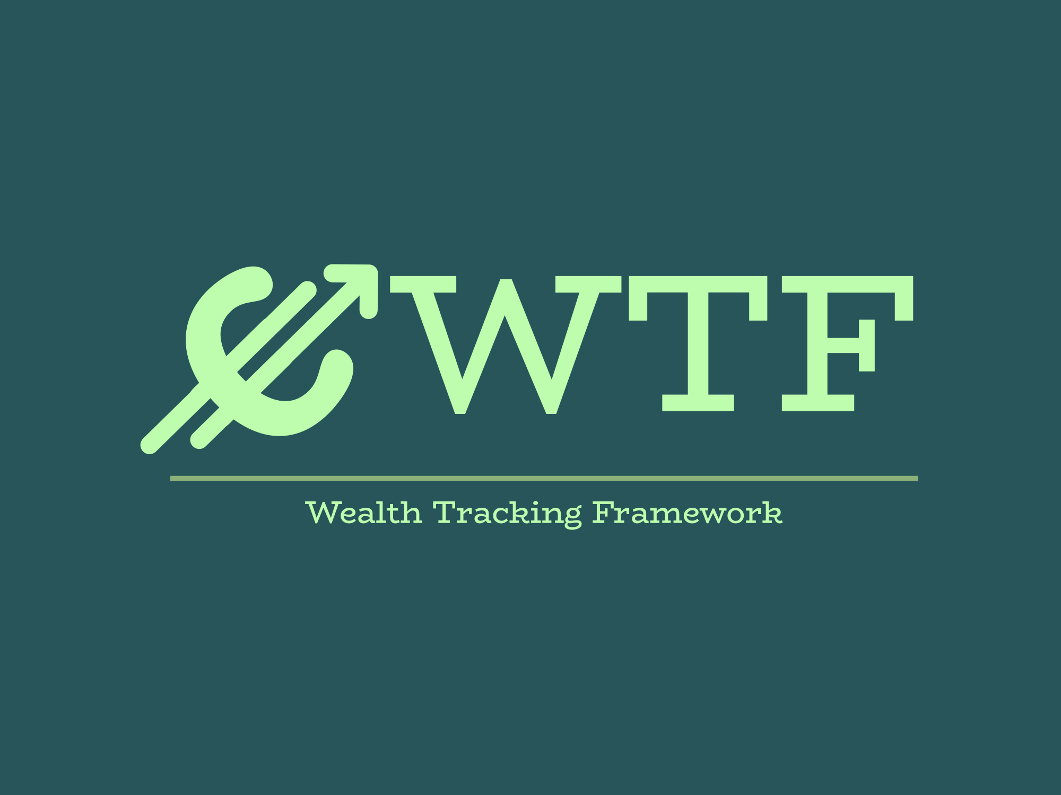

**Declaration**

This project is presented in partial fulfilment of the requirements for the degree of Bachelor of Engineering (Honours) in Software and Electronic Engineering at Atlantic Technological University.

This project is my own work, except where otherwise accredited. Where the work of others has been used or incorporated during this project, this is acknowledged and referenced.

Signed:

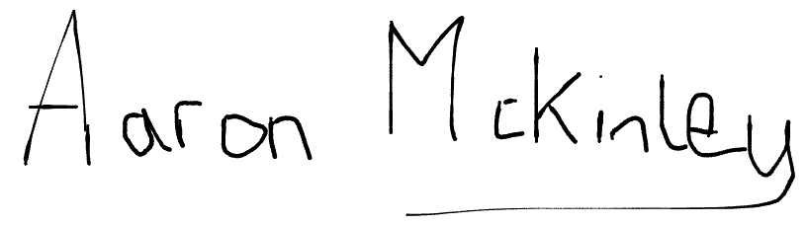

**Acknowledgements**

I’d like to thank Fergus Downey for meeting with me every week and keeping me on track with clear guidance throughout the project. Thanks also to Des O’Reilly for always being on the students’ side, and to all the lecturers in ATU for their help over the years. Most of all, thanks to my partner Danielle for putting up with me spending so many hours buried in this project.

Table of Contents

1 Summary 6

2 Poster 7

3 Introduction 8

4 Background 9

5 Project Architecture 10

6 Project Plan 11

6.1 Workload breakdown 12

7 System Development 13

7.1 Docker 14

7.1.1 Containers 14

7.1.2 Dockerfiles 15

7.1.3 Docker Compose 16

7.2 PostgreSQL 17

7.2.1 Migrations 17

7.2.2 Database Structure 17

7.2.3 Database Backup 17

7.3 Node.js and Express 20

7.3.1 Index.js 21

7.3.2 Middleware 22

7.3.3 Routes.js 23

7.4 React 31

7.4.1 TypeScript vs JavaScript 31

7.4.2 JWT Authentication 31

7.4.3 Routes 32

7.4.4 Auto Fill 34

7.4.5 Auto Calculate 35

7.4.6 Buy and Sell Mode 37

7.4.7 Dashboard 38

7.5 Ansible 39

7.5.1 Playbooks List 39

7.6 Jenkins 42

7.6.1 CI/CD 42

7.7 Fetchers 48

7.8 Cypress 52

7.8.1 Locators 54

7.8.2 Spec and Actions 54

7.8.3 Results Output 57

7.9 Nginx 58

7.9.1 Nginx Deployment and Issues 58

7.9.2 Nginx Proxys 58

7.9.3 Nginx Proxy Jenkins Example 58

7.10 Allure 60

7.11 Hetzner Server. 61

8 Ethics 62

9 Conclusion 63

10 Appendix 64

11 References 65

# Summary

For this final year project, the plan was to cover two main targets: to create a useful tool and demonstrate DevOps principles. This led to the idea Wealth-Tracking-Framework.

There are lots of platforms for investing but most only deal with one type of asset such as stocks or cryptocurrencies and it can be hard to keep track when investments are in different places. This can be addressed by building an application that brings assets together into one place to be tracked and provide live price updates across multiple types of assets.

The project followed Agile methodologies it was split into week-long sprints with weekly stand-ups. Each sprint was meant to deliver a defined piece of functionality, with later sprints integrating components into the working application.

The application is containerized using Docker, with Docker Compose for orchestration. Each component runs in its own container creating a microservices-inspired architecture. The application stack consists of a React and Tailwind frontend, a Node.js backend, a PostgreSQL database, CoinGecko and Finnhub fetchers (APIs for live prices) and Nginx for static files and proxy API requests.

Jenkins acted as the heartbeat of the DevOps workflow. Code pushes triggered an automated pipeline that built and published Docker images, deployed them with Ansible, and then ran Cypress tests and linting to ensure code quality, with defects opened on failure.

The project resulted in a functional multi-asset tracking web application with live pricing, portfolio tracking and user sign-up with JWT authentication. The DevOps workflow was demonstrated through containerisation, automated deployments and CI/CD testing pipelines.

# Poster



# Introduction

The aim of this project was to develop a full stack application for wealth tracking while demonstrating DevOps workflows and architecture. This would in principle give people a place to help track their investments to give a better idea on funds available for retirement, discretional spending, mortgage deposit or plain old savings. This will hopefully help and motivate people to save for the future by making it easily trackable and increase financial literacy.

As I have been working for some years in a DevOps role and recently moved to Automation I wanted to incorporate some workflows I have become accustomed to using but had never built myself in my role in DevOps. Then with my recent move to automation having never worked with end user automation testing before I wanted to use this project as a chance to expand my learning in Cypress. This all led to the full stack DevOps architecture with the self-finance aspect that I have an interest in.

The problem I am trying to solve is the fact that having started my investment journey outside of a big spreadsheet that does not have live prices I have no way of knowing my net worth as all that information is stored across several different apps. With Wealth Tracking Framework anyone can log on and start tracking their portfolio with live updates on multiple assets as well as savings account trackers that calculate the interest earned. There are no good platforms that currently offer a simple multi asset tracking for the everyday person to use that also lets you see your total net worth.

The scope of the project covers both software development and DevOps workflow design. A full stack CRUD application was built. React for the frontend, Node for the backend, PostgreSQL for the database and fetchers using two APIs for the live data. All this is supported by the automated containerization, deployment and testing. This demonstrates the principles of Agile delivery and DevOps automation while also having a working modern web application.

# Background

Retail investors have been able to access financial markets more easily over the past few years. Fractional shares, combined with the trend towards zero- or low-fee investing, have made trading accessible to everyone, while user interfaces on the platforms that support these investments are usually excellent and offer the basic ability to track one’s assets. The limitations become apparent when considering the range of assets supported.

Cryptocurrencies make this need even more obvious. Following the collapse of the centralised exchange FTX, the phrase “not your keys, not your crypto” gained popularity meaning the risk of leaving assets on centralised platforms without full control or insurance. As a result many investors now hold their coins in personal wallets across multiple locations. While this improves security and control it makes portfolio tracking really difficult as assets are spread across exchanges and wallets.

For this reason many investors still rely on spreadsheets such as Excel to track their portfolios. While Excel has built-in support for stocks it requires a lot of manual work to integrate cryptocurrencies. Free tools exist but they are limited usually to either stocks or cryptocurrencies or do not have saving options.

Empower is one of the best free options it has lots of stocks and good price tracking and a savings planner, but it does not support live crypto data only self inputs. CoinMarketCap’s portfolio tracker is excellent for cryptocurrencies but cannot track other asset types. Paid platforms such as Kubera provide a better service but a subscription cost leaves it out of reach for most people.

**The Wealth Tracking Framework (WTF)** is designed to fill this gap. It combines the flexibility and control of spreadsheets with the ease of a modern web application offering free multi-asset tracking across stocks and cryptocurrencies. Also, WTF supports high-yield savings accounts including those that compound more frequently (daily or monthly), giving users a clearer view of their true net worth than traditional tools provide.

# Project Architecture

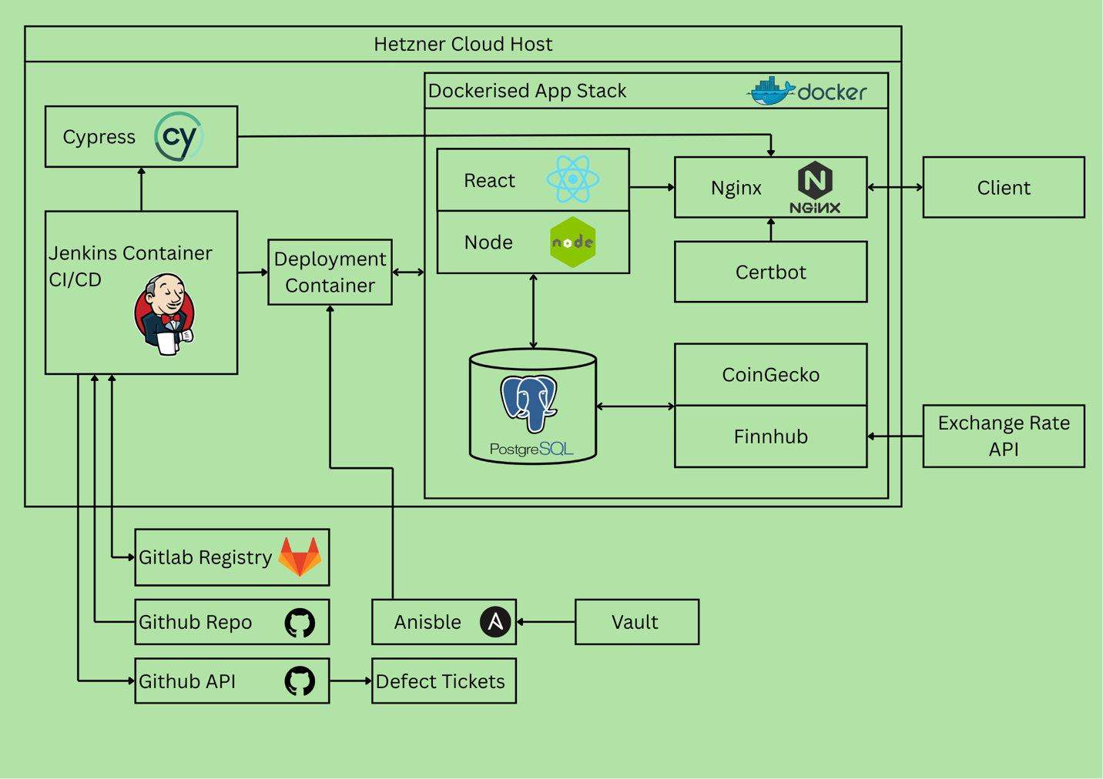

# Project Plan

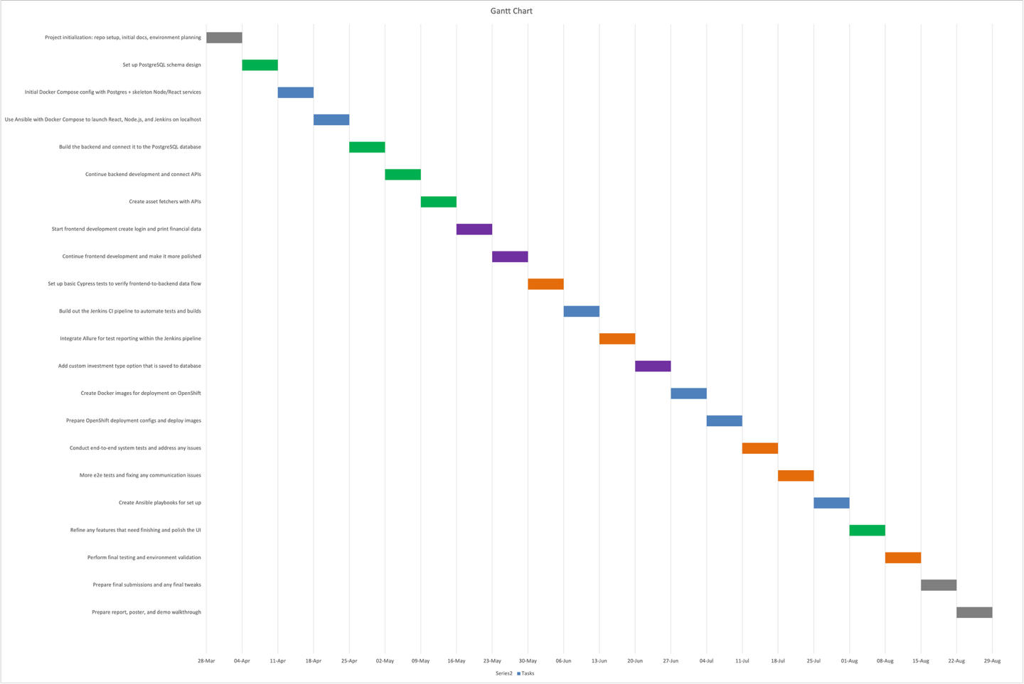

|  |  |
| --- | --- |
| Type of work | Colour |
| Admin/Documentation |  |
| Backend |  |
| Frontend |  |
| Infrastructure |  |
| Testing |  |

## Workload breakdown

The project was split into week-long sprints, with a stand-up meeting held every Friday. Each sprint focused on a specific task to be completed, while later sprints worked on integrating the different parts together to build the full application. This approach shows an agile mindset, since if multiple people were working at the same time, tasks could have overlapped and progressed in parallel rather than finishing one layer before moving to the next.

* Mar 28, 2025: Project initialization: repo setup, initial docs, environment planning
* Apr 4, 2025: Set up PostgreSQL schema design
* Apr 11, 2025: Initial Docker Compose config with PostgreSQL + skeleton Node/React services
* Apr 18, 2025: Use Ansible with Docker Compose to launch React, Node.js, and Jenkins on localhost
* Apr 25, 2025: Build the backend and connect it to the PostgreSQL database
* May 2, 2025: Continue backend development and connect APIs
* May 9, 2025: Create asset fetchers with APIs
* May 16, 2025: Start frontend development create login and print financial data
* May 23, 2025: Continue frontend development and make it more polished
* May 30, 2025: Set up basic Cypress tests to verify frontend-to-backend data flow
* Jun 6, 2025: Build out the Jenkins CI pipeline to automate tests and builds
* Jun 13, 2025: Integrate Allure for test reporting within the Jenkins pipeline
* Jun 20, 2025: Add custom investment type option that is saved to database
* Jun 27, 2025: Create Docker images for deployment on OpenShift
* Jul 4, 2025: Prepare OpenShift deployment configs and deploy images
* Jul 11, 2025: Conduct end-to-end system tests and address any issues
* Jul 18, 2025: More e2e tests and fixing any communication issues
* Jul 25, 2025: Create Ansible playbooks for set up
* Aug 1, 2025: Refine any features that need finishing and polish the UI
* Aug 8, 2025: Perform final testing and environment validation
* Aug 15, 2025: Prepare final submissions and any final tweaks
* Aug 22, 2025: Prepare report, poster, and demo walkthrough

# System Development

The idea behind the project Wealth Tracking Framework(WTF) was to create an app that could use DevOps methodologies for development. The basic frontend, backend and database were the first step. This was followed by creating the docker files and docker compose file to deploy these services on localhost. Ansible playbooks were then create to automate the setup and deploy our app services to the front end. The asset fetchers were then created CoinGecko for cryptocurrencies and Finnhub for stocks. Each got its own container and posted the fetched data to the database. Cypress tests were then created to test the login which were able to be locally. Jenkins pipelines were created. There were real issues with creating a container that had permissions to view pages that were running on localhost so when the test pipeline ran it could not access the React frontend. As the plan was to move to the cloud this was scrapped. The front and back ends were then completed and the whole stack was deployed to the Hetzner server. There was an issue when building images locally as that was different architecture (MacOS) to the AMD server so a proxy was created so the build images were correct. This was removed when building the images with Jenkins on the server so the proxy was no longer needed. The deploy pipeline was created that had plenty of hurdles (covered in the Jenkins section) Followed by the test pipeline. The Cypress test suite was then expanded to cover all the possible user interactions. Finally, the ticketing process using the GitHub API was added to track defects.

## Docker

Docker was one of the tools that was used most in WTF no other options were considered as it is one of the most common tools in industry and was a key part of the project [19]. It was essential in getting the application running and what was learnt while using it was invaluable. Docker and specifically compose made the process much simpler. Having the one YAML file and having the services on the one docker network greatly simplified the process and allowed for a one command deployment.

### Containers

WTF has each service containerized. Running on the server there are 9 containers in total, with 7 running continuously (Figure 7.1.1). The wtf-deploy container that is created by Jenkins deployment pipeline exits successfully upon completion and the wtf-react container exits after building and delivering its static files to NGINX. This is standard practice in containerized frontend deployments: React builds once and hands over static assets, rather than running a live React server in production.

Figure 7..1 - Containers

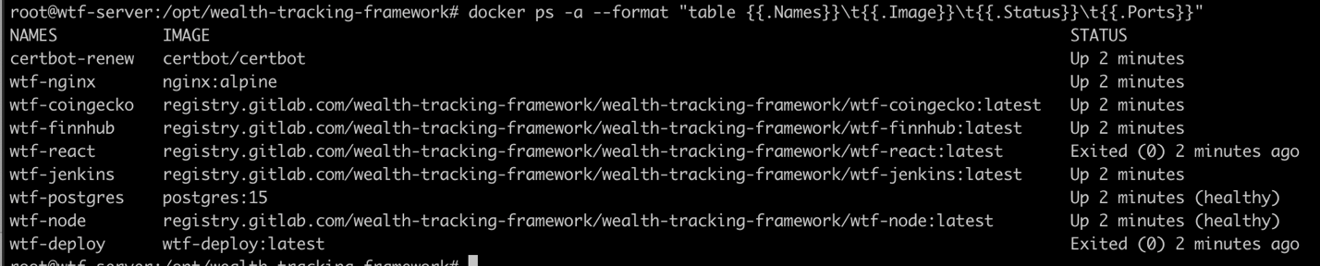

Three of the containers that are running in WTF are based on standard public images, while the remaining services are built from custom Dockerfiles (Figure 7.1.2). Specifically, PostgreSQL uses the postgres:15 image, Nginx uses nginx:alpine, and Certbot uses certbot/certbot. We did not require any specific functionality beyond what these default images already provide, so custom Dockerfiles were unnecessary for these three services.

### Dockerfiles

There are 6 custom Docker images and each has their own Dockerfiles, which not only specify what dependencies need to be installed and what files should be copied in, but also configure build steps, set environment variables, define entrypoints and commands, and include any project-specific setup required for the services to run consistently.

The Node Dockerfile (Figure 7.1.2) provides a good example of how our custom images are defined. It sets the working directory, declares an environment variable, copies the package files from the repository, installs the dependencies, and then copies the full source code into the container. It also exposes the backend port and specifies *npm start* as the command to run, which launches the backend service.

Figure 7.1.2 – Node Dockerfile

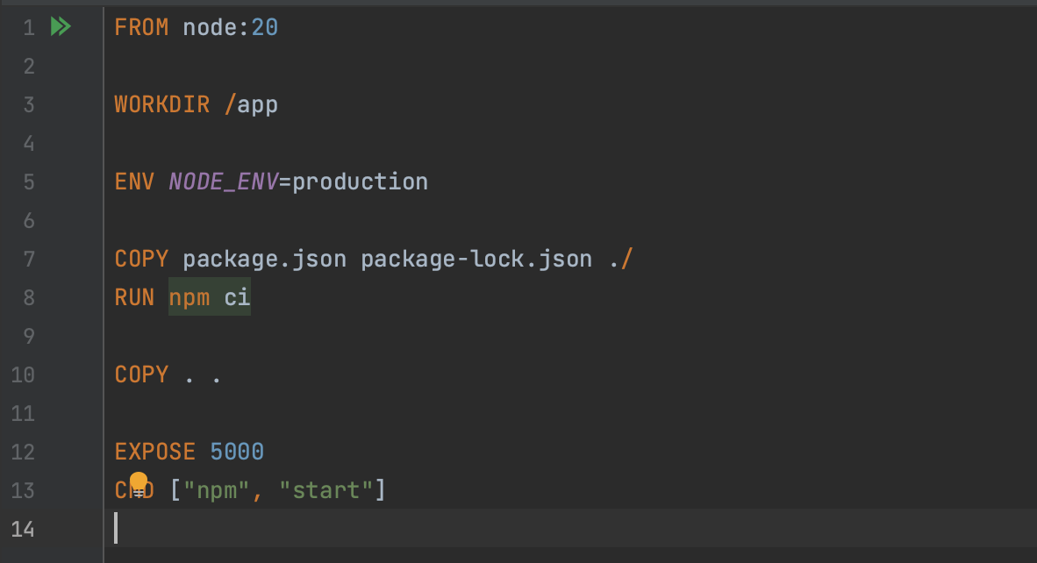

### Docker Compose

Docker Compose works by defining multiple services in a single YAML file. It then orchestrates them into one application. Each service has its own configuration. React is a good example of how Docker Compose works in practice (Figure 7.1.3). Unlike the Node.js service, which does not make use of volumes, the React definition shows how Compose manages a build context for building the image, attaches a volume which is just a copy of files for Nginx to get the static files, defines dependencies on other services and connects the container to the shared wtfnet network [3].

The wtfnet network allows WTF services to communicate internally without exposing unnecessary ports. By joining the same bridge network, containers can reach each other by service name instead of ports.

Figure 7.1.3 – React Docker Compose

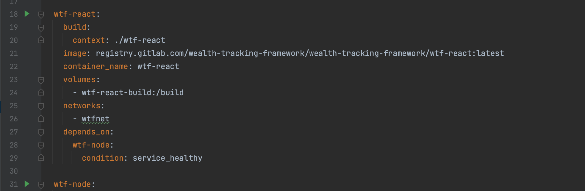

## PostgreSQL

For the databases choice SQL was a necessary choice. Financial data requires accuracy and strict structure which a NoSQL database like MongoDB or CouchDB would not provide.. SQLite was not ideal for multi user financial data and Oracle is more for enterprise level. That left MySQL and PostgreSQL with PostgreSQL being chosen as it is more commonly used in industry where and its stronger support for data integrity and financial calculations [4].

### Migrations

This method was used for the database creation because the application was constantly being redeployed to test new changes so a method of database initialisation that was consistent (Figure 7.2.2). Migrations also work well with Ansible which was the automation tool of choice as well as being written in JavaScript the language of choice for the project.

### Database Structure

The structure of the database revolved around the user table. The cryptocurrency table and stock table is updated by the Fetcher containers which use the APIs for up to date asset data and is updated regularly. The seed dummy data table is a migration that adds test data to the application. The main structure of the database can be seen in Figure 7.2.1. Each user has an entry in the Users table. When a user creates a transaction it gets data from the Fetcher databases and adds it to the Transaction table. The buys and sells in the Transaction table is added together and put in the Investment table which is shown on the main dashboard

### Database Backup

There is a simple backup method set up on the server the containers are running on. A cronjob was created that the backup command *pg_dump* every night. The cronjob also backups up the Jenkins jobs and configuration for easy redeployment if needed(Figure 7.2.2) [18].

Figure 7.2.1 – Database Structure

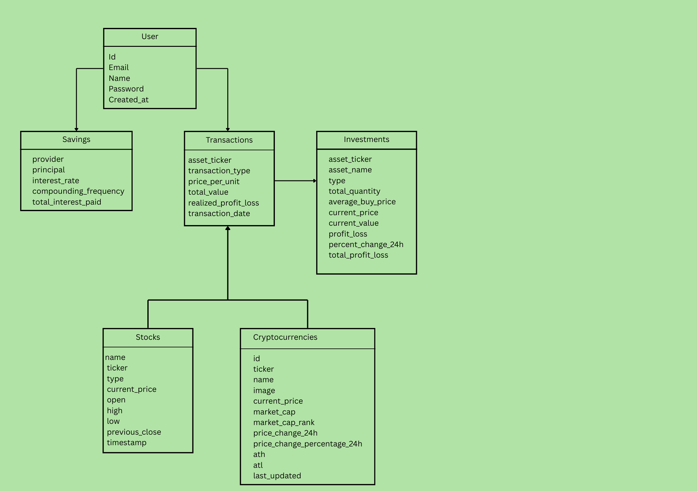

Figure 7.2.2 –Migration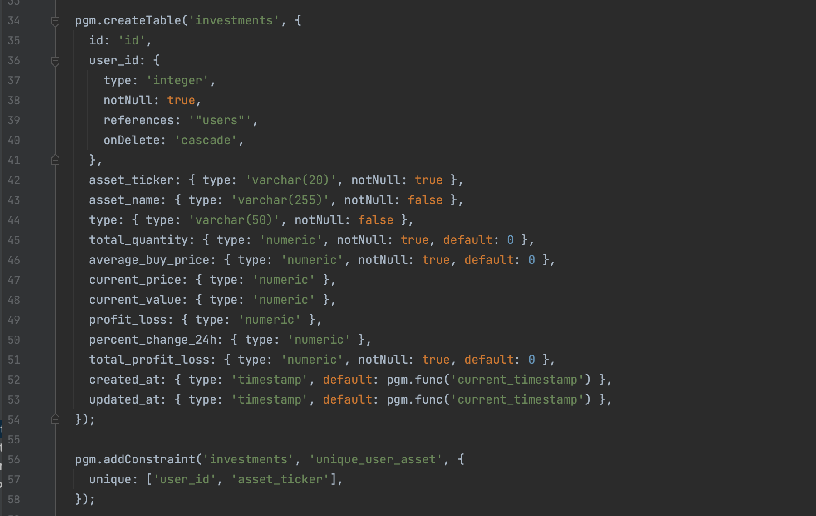

Figure 7.2.3 – Backup Cronjob

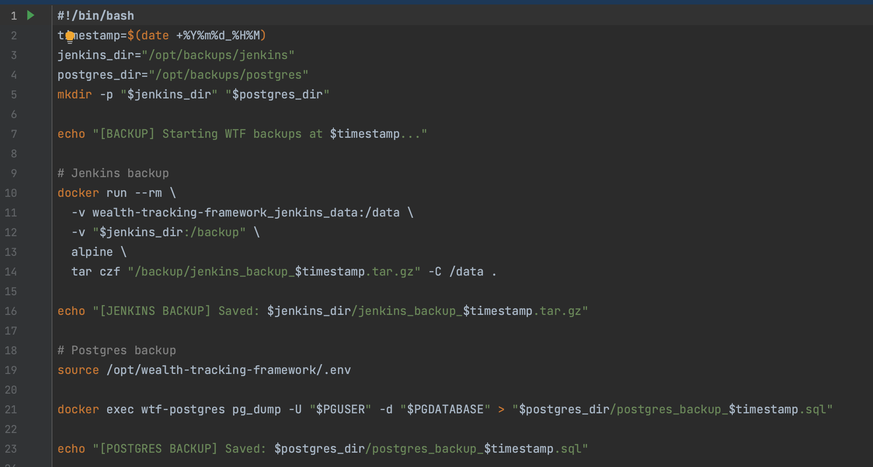

## Node.js and Express

Node.js is one of the most widely used backend runtimes and suits the lightweight backend WTF needs. The backend is only needed for the API layer The backend is implemented with Express which manages authentication, CRUD operations, user data, and the calculation of investment information from the database. The choice of Node.js was easy as it works well with React and allows the same language to be used across both the frontend and backend [7].

The diagram (Figure 7.3.1) shows how a request from the Client moves through the layers of the backend. A HTTPS request from the client is received by Nginx which is acting as a reverse proxy (Nginx is explained in detail in the Nginx section). Nginx forwards the /api/*, any backend request, to the correct port that is only exposed between containers over the Docker network. Once Node receives a request Express takes over [8]. The request goes through 2 stages. Its first handled by middleware which ensures it’s a useable object, ticker, quantity and price, or it throws an error. It then verifies it came from a user with a valid JWT token. Express then passes it on as a route to the correct route where the application logic runs. Finally, the route gets or updates information in the database.

Figure 7.3.1 –Node Request Flow

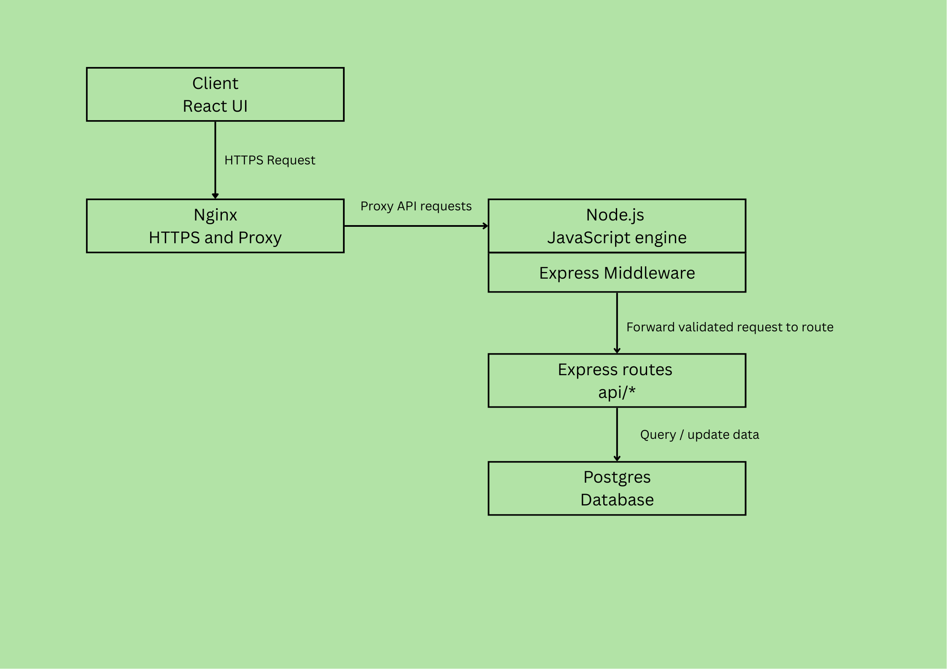

### Index.js

The index.js file for Node in WTF is mostly boilerplate but has a few critical features. It makes sure the JWT is set, adds the express middleware for JSON parsing and CORS and it has a healthcheck as its critical infrastructure. CORS (Cross-Origin Resource Sharing) is enabled so that the React frontend can communicate with the API even though they run on different ports inside Docker. and has a health check as if the wtf-node container is not working the rest of WTF will not be able to talk to the other services.

Figure 7.3.2 – index.js

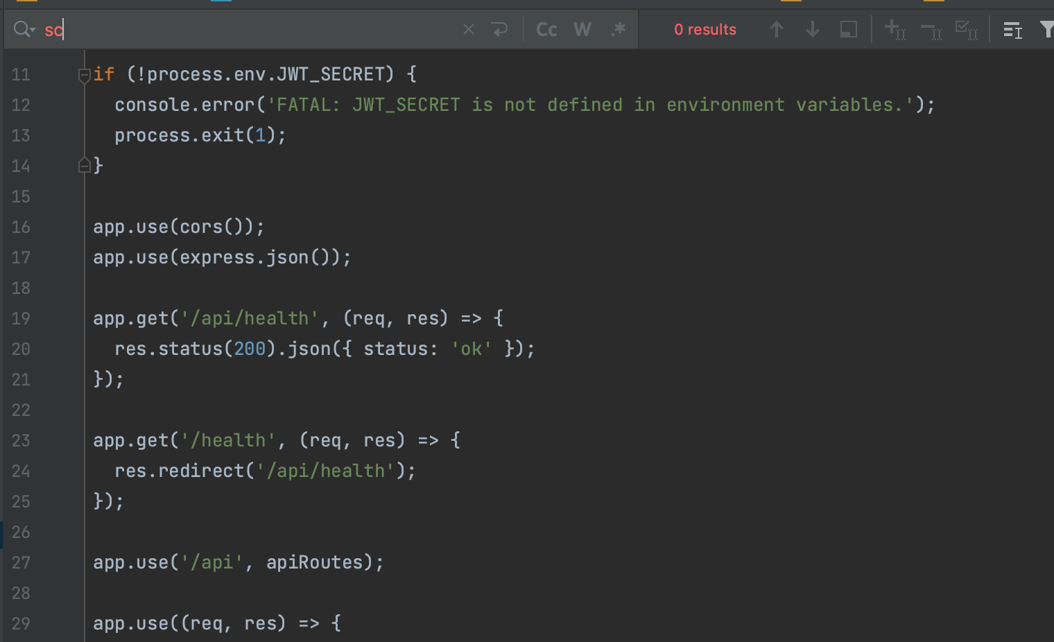

### Middleware

The middleware is a checkpoint between layers. This is where the JWT authentication is done. If there is no token provided Express returns a 401 response. If there is a token it verifies it against the JWT_SECRET that is defined in the .env file that Ansible generates from the vault. Invalid or expired tokens give a 403 response. Valid tokens are decoded and the user details are added to the request. Once complete the middleware calls next() to pass the request to the correct route.

Figure 7.3.3 – Middleware

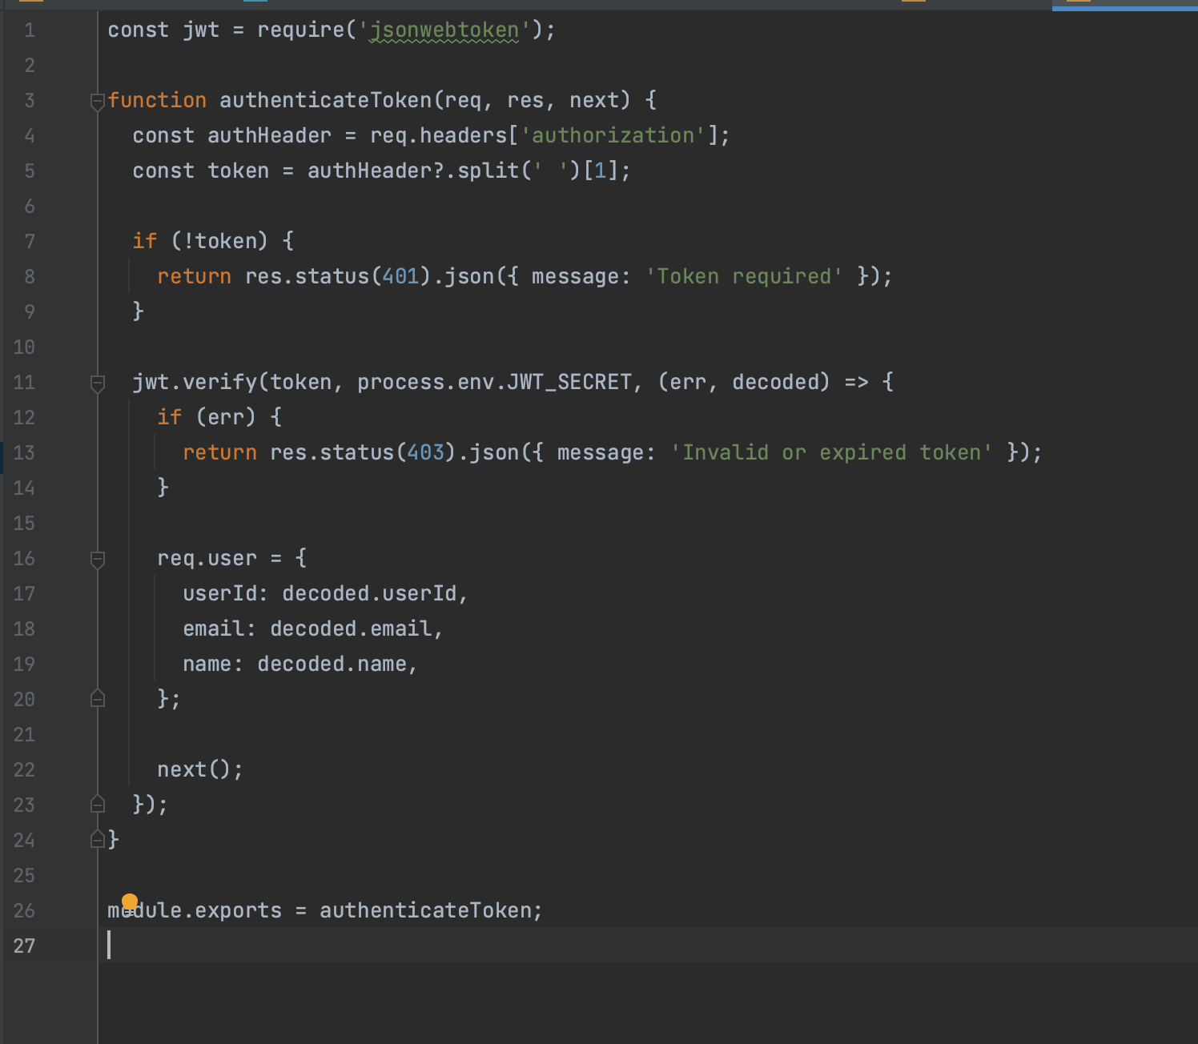

### Routes.js

This is the file where the backend logic sits. It does all the calculations and contains all the API routes for the WTF pages. Each route is for a specific endpoint under /api. The routes manage everything authentication, investments, transactions, savings and user profiles. It connects directly to PostgreSQL updating or getting data from the database returning JSON to the client.

#### Buy/Sell

The buy and sell routes are where the maths for each investment happens. The buy route is where new investments are added. Each buy is recorded as a transaction and the total for that asset is calculated as total buys minus total sells.

It then works out the average buy price. This is done by taking the sum of the asset bought multiplied by the prices it was bought at and dividing it by the total buy amount. The price per unit for the current buy is also calculated by dividing the total value by the quantity.

The sell route does the same but takes it away. It checks the number is valid and rejects any invalid quantities. It also blocks a user from selling more than they currently hold.

Once a sell has gone through the code calculates the realised profit or loss by taking the difference between the sell price and the average buy price multiplied by the amount sold. The remaining asset is then updated by subtracting the amount sold current total.

Figure 7.3.4 – Buy/Sell Maths

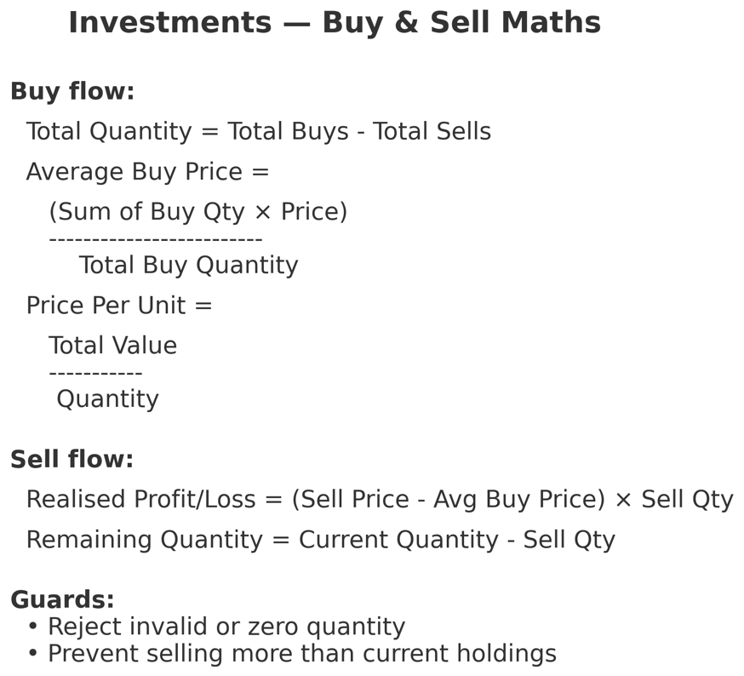

Figure 7.3.5 – Error Handling

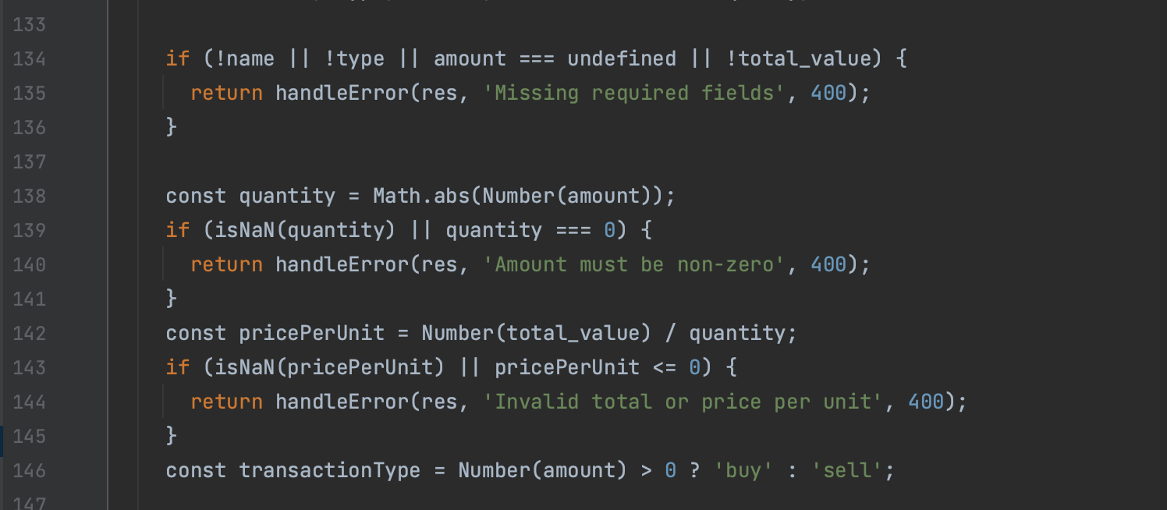

Figure 7.3.6 – Inserting into PostgreSQL

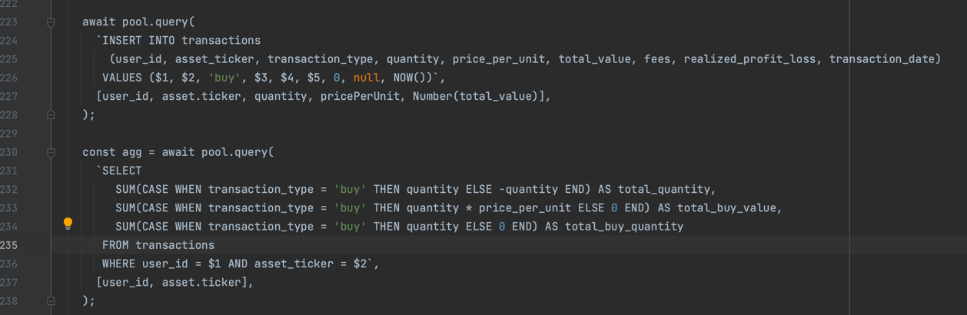

Figure 7.3.7 – Sell

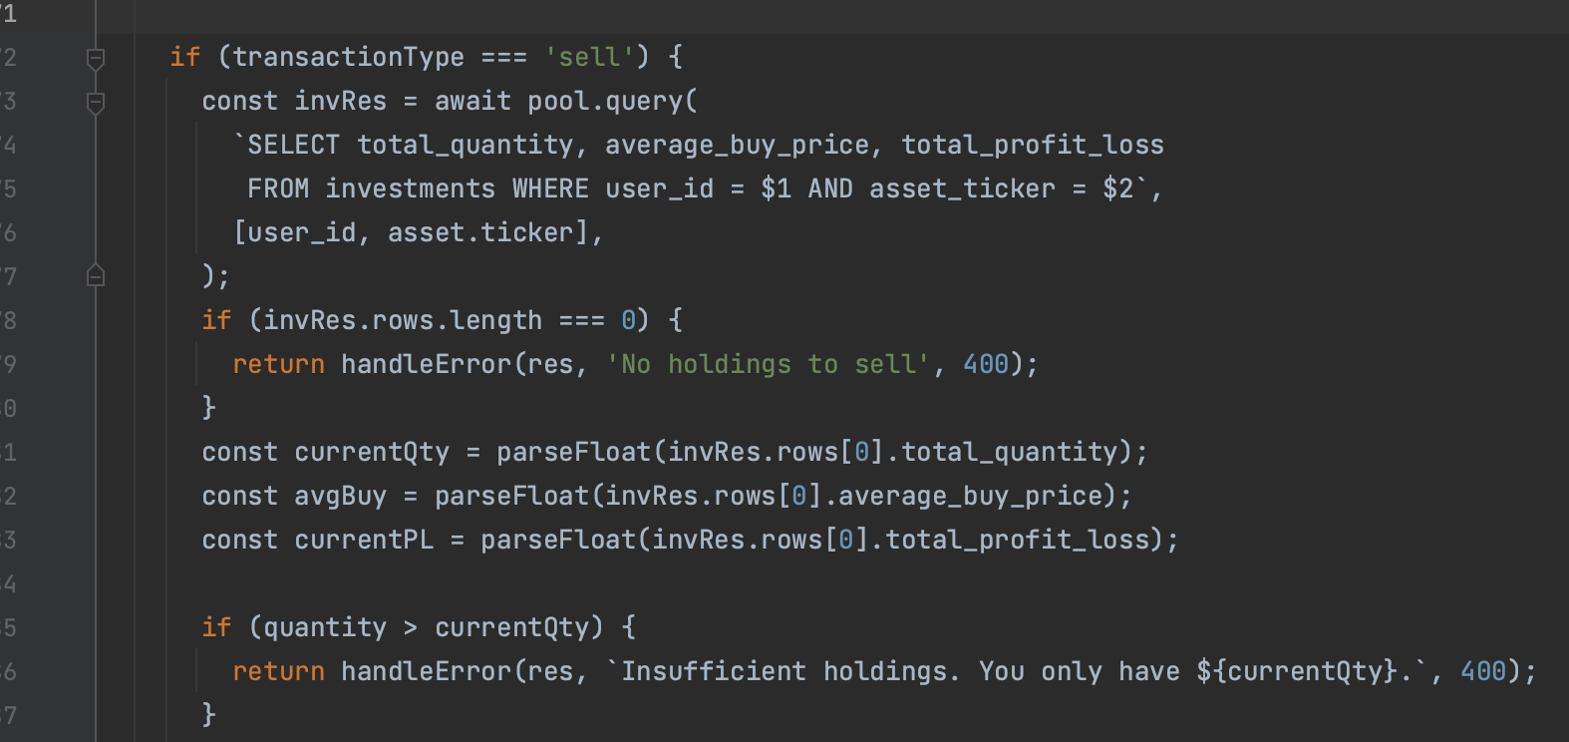

#### Portfolio

The dashboard page shows the users investments table. This is each asset from the transaction table calculated to show how much of each is owned. The total value and the profit/loss is calculated and is visible at the top of the page. The current value is the current price multiplied by the total quantity. Profit/Loss is calculated from the unrealised P/L and the realised P/L added together. The P/L is the current price minus the buy price multiplied by the quantity. No live API request are made from the Fetchers here there is only communication with the database.

Figure 7.3.8 – Portfolio Maths Formula

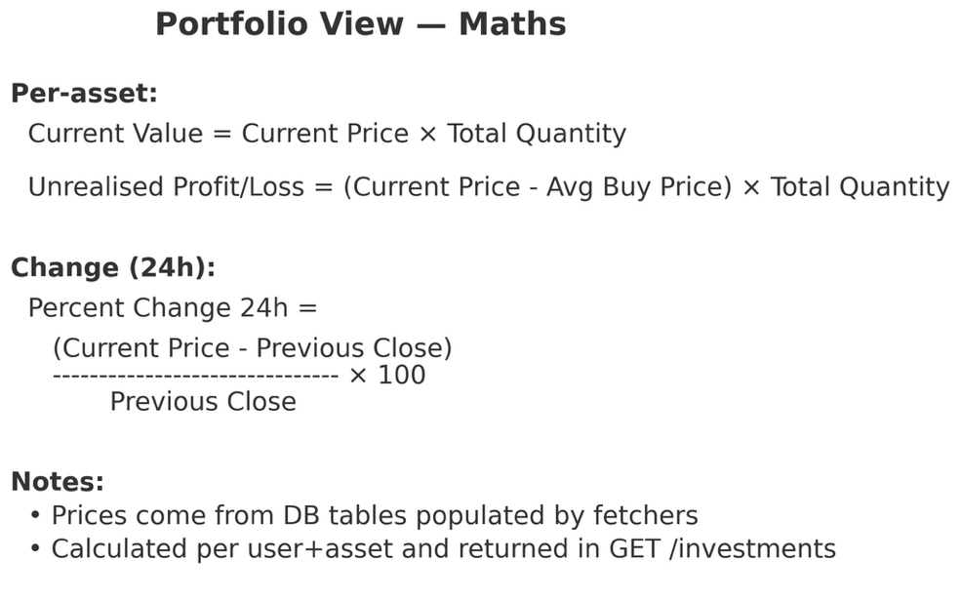

Figure 7.3.9 – Portfolio Maths Code

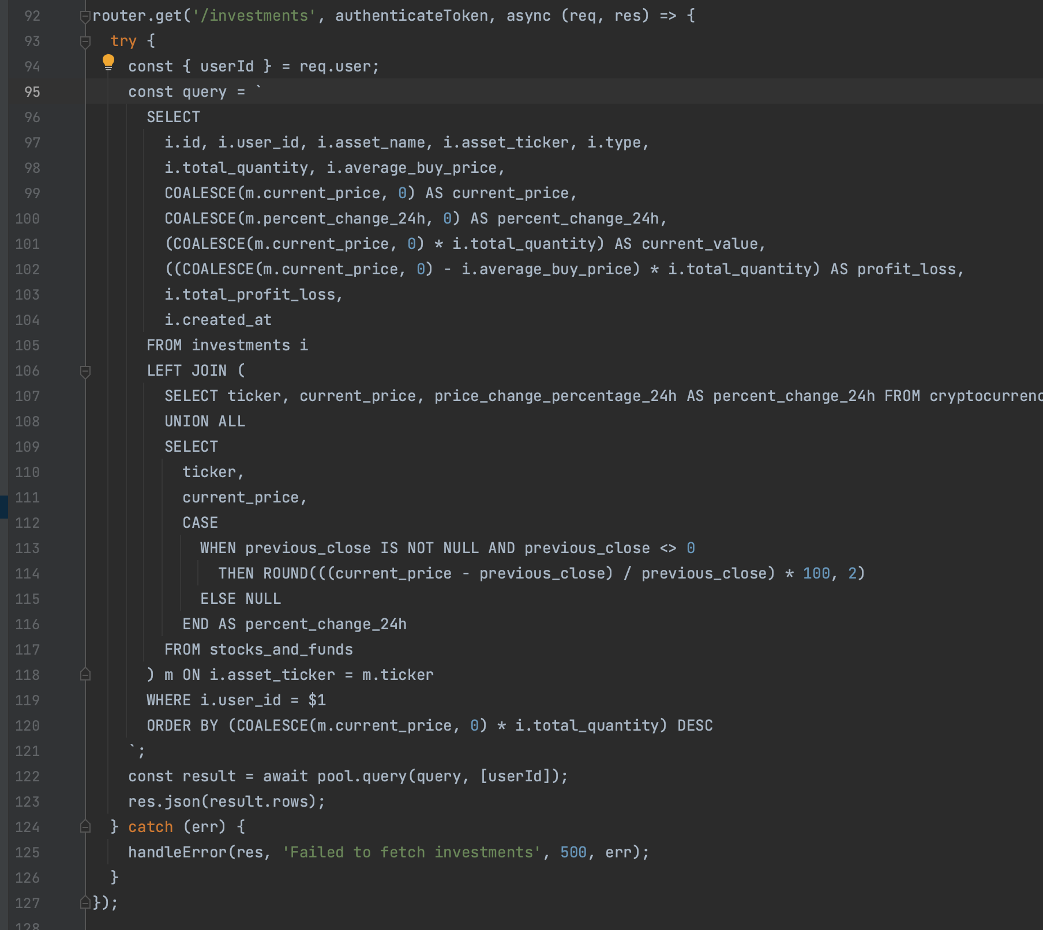

The portfolio route runs a single SQL query that adds the user’s investments with the latest prices from the cryptocurrency and stock tables. It uses COALESCE to fall back to zero if a price is missing which avoids null errors but means an asset without a price will temporarily show as zero. A UNION ALL adds the two asset types into one table for the join. The current value and profit or loss is calculated directly in the SELECT statement while the 24-hour change comes from the database for cryptocurrencies or is calculated using the current price with the previous close for stocks and funds. Finally, the results are ordered by value, so the largest holdings appear first.

Figure 7.3.10 – Sell

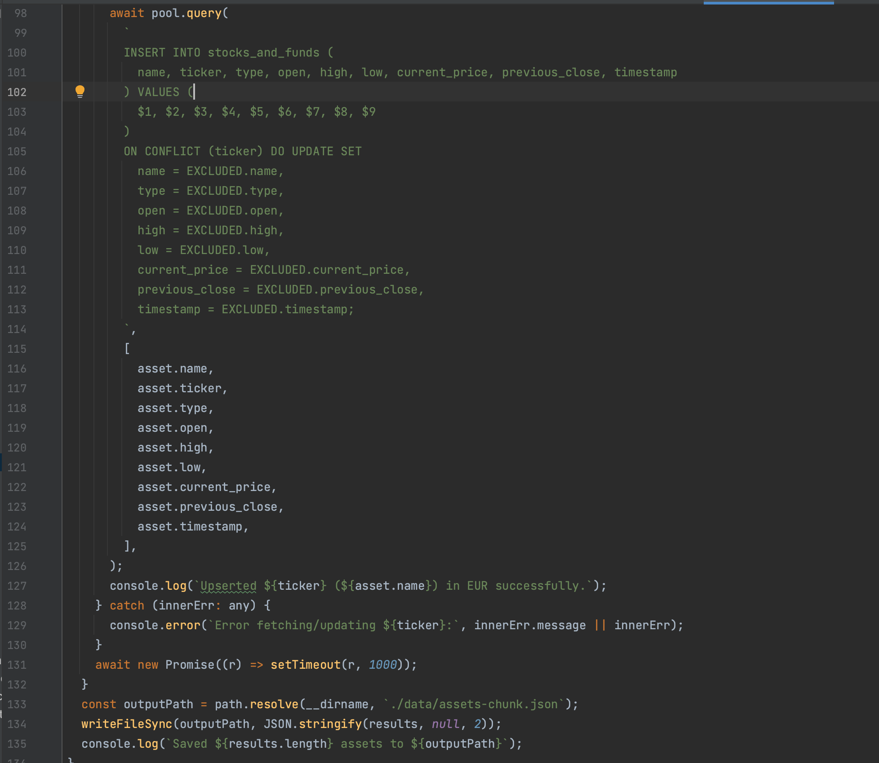

#### Savings

The savings routes handle deposits and withdrawals for savings accounts and apply compound interest to calculate money earned. Each account stores the principal, interest rate and compounding frequency. On every request to /savings the backend runs a helper function that applies the compound interest formula where the future value is calculated as:

Compounding balance = principal × (1 + interest rate ÷ compounding frequency) ^ (compounding frequency × time)

This shows the next payout which is calculated as the difference between the future value and the current principal. This means each account shows both its running balance and the next expected interest payment.

Figure 7.3.11 – Compound Interest

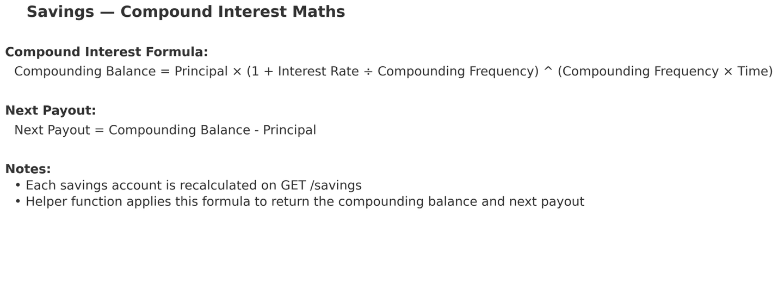

The route processes each savings account by passing its balance, interest rate, and compounding frequency into the calculateCompoundSavings helper. This calculates the next_payout which is then added to the savings data. The response gives both the stored balance and the upcoming interest payment. This gives a clear picture of interest payments and the compounding growth.

Figure 7.3.12 – Get Savings

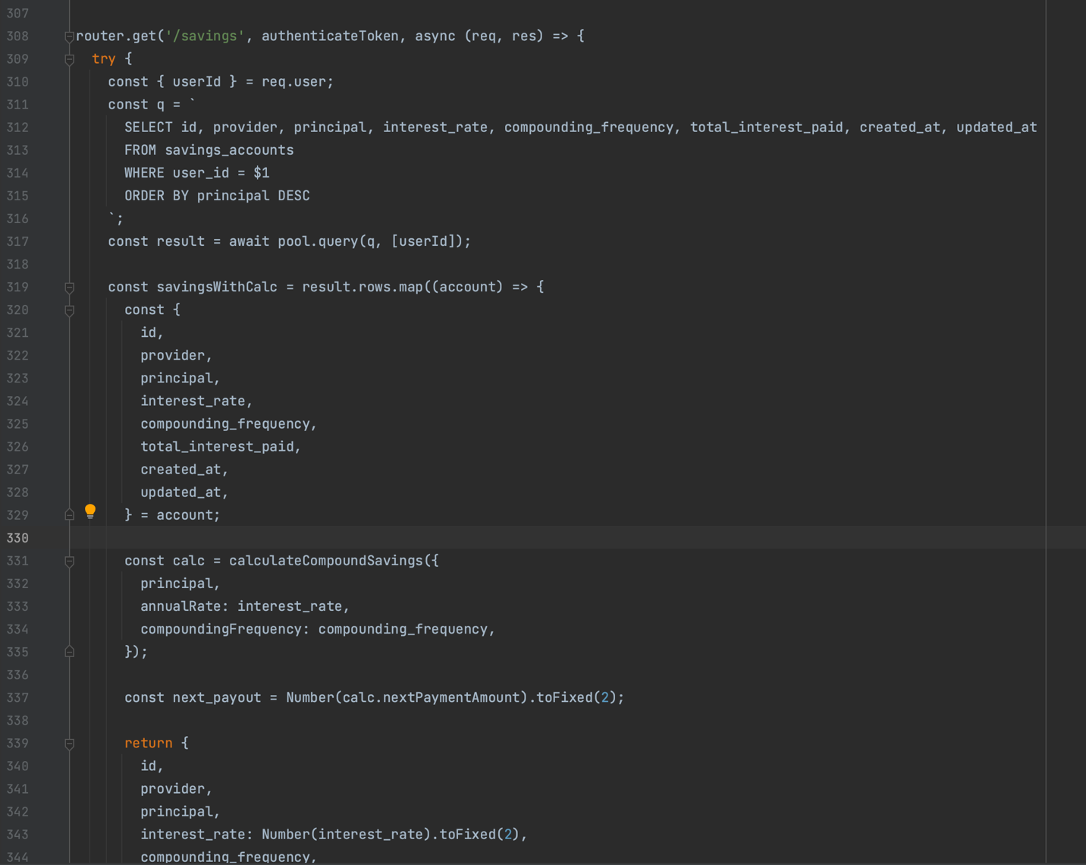

When a new savings account is created the route runs the account through the calculateCompoundSavings helper to see the projected next interest payment. This value is then put into the database alongside the user ID, provider, principal, interest rate, and compounding frequency. Storing the next_payment_amount at creation means each account is set up with its balance and upcoming interest payout already calculated.

Figure 7.3.13 – Create Savings

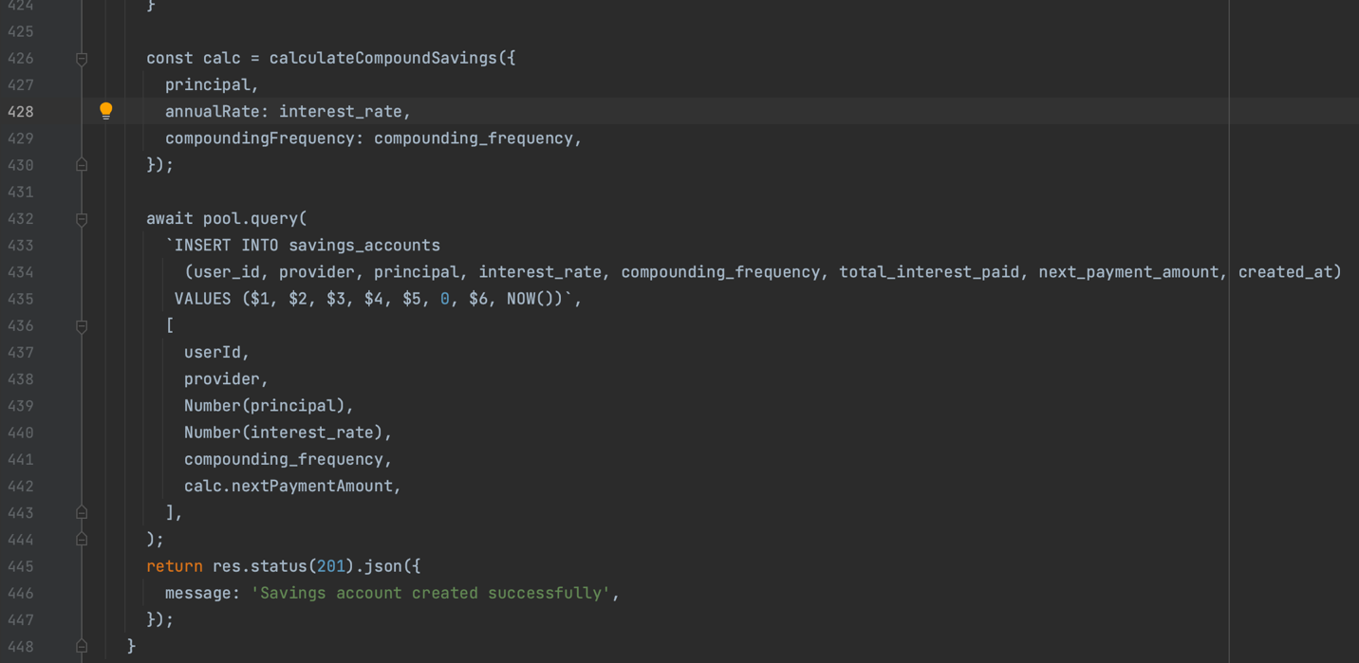

## React

React was used for the front end. Other options considered were Vue and Angular but due to React having the best documentation and being the industry standard it was the obvious choice. React was chosen for its reuseable components and for its ability to easily work with REST APIs which are used in the backend [1]. Alongside React, Tailwind was used as the CSS framework. Tailwind was chosen because it allows for rapid UI development without the need to write large custom CSS files. It provides a utility-first approach that ensures a consistent design [2].

### TypeScript vs JavaScript

TypeScript was the main language used in WTF instead of plain JavaScript. TypeScript is converted to JavaScript when being compiled This was used because it enforces static typing, meaning variables and functions must be given specific types (e.g. string, object) that the compiler checks. This allows bugs stemming from mismatched types to be caught early instead of only appearing on the client. This is especially useful in a multi file project and even though JavaScript sets up quickly and is more flexible TypeScript's type annotations leads to far easier debugging for stronger code [16].

### JWT Authentication

The basic utility of Login and AddInvestments talking to the back end worked well when completed but there was an issue. Security was not considered and using the /dashboard route could be accessed any time without login. This led to finding the solution of using JWT (JSON Web Token) authentication across the frontend and the backend. JWT is a lightweight stateless method to verify users every time a request is made [9]. JWT is perfect for multi container solutions as the JWT token is stored on the client and is added to the API requests without running another service on the server. While this was the correct solution it broke everything. After changing the routes to private they began to reject the JWT token.

The solution came in adding the apiClient which attaches the JWT token to every request made, routes that should have only been accessed after login were changed to private routes and AuthContext.tsx kept track of whether the user was logged in and stored the token [24]. With this and a lot of Server Errors (poor error messaging that was eventually improved on) the information and pages that should only be available on Login were hidden to each particular user.

### Routes

There are 3 public routes Homepage, Login and Signup. If a bad URL is entered when not logged in or a private route the public routes redirect to the Login page. After Login or signup and the private routes can be viewed a wrong URL goes to the 404 error page which leads back to the Dashboard (Figure 7.4.1)

Figure 7.4.1 – Routes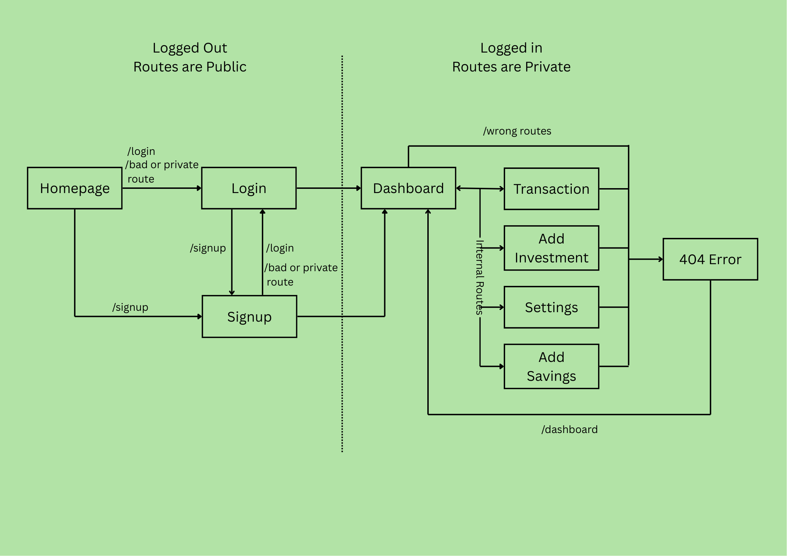

Figure 7.4.2 – App.tsx-Routes

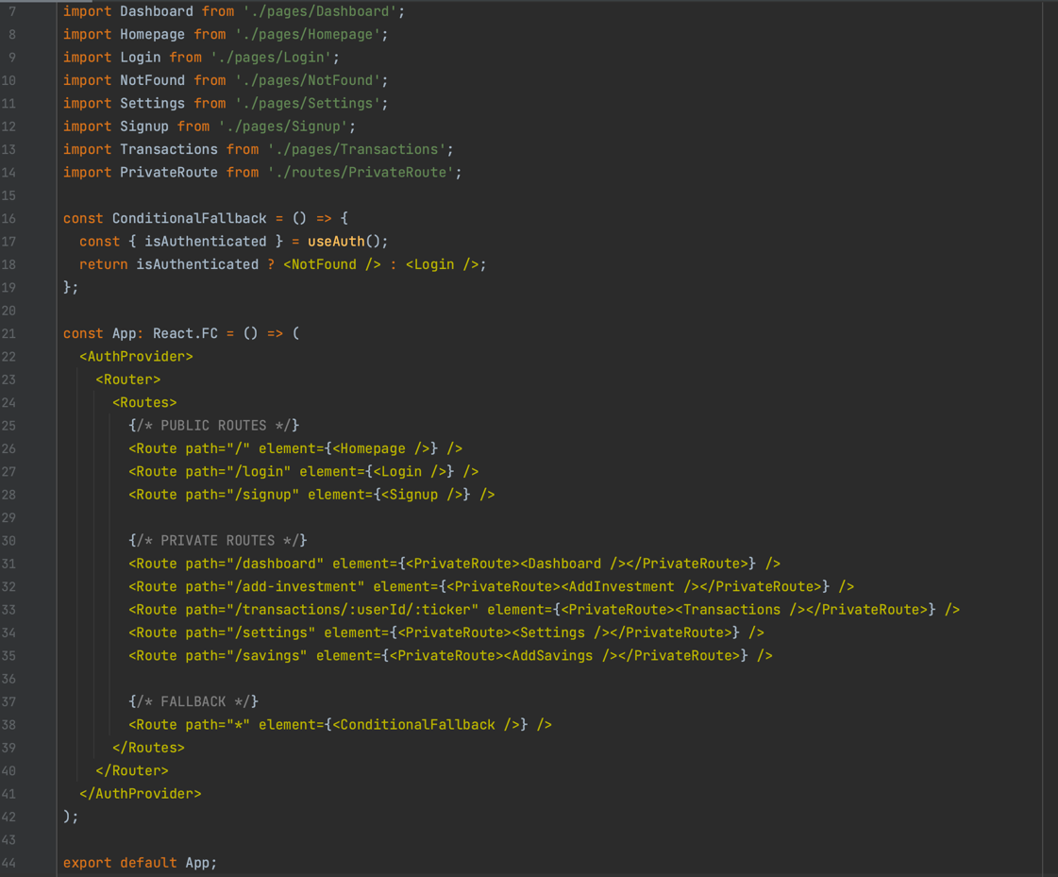

### Auto Fill

When a user logs in they see the dashboard where they can click Add Investment to start tracking their assets. This brings them to a form where they can type the ticker which is the unique code that all assets have. When the user starts typing a dropdown list of suggestions lets them know what is available. The user then clicks the asset they want. React filters the local ASSETS list based on the search input and updates the suggestions. When a suggestion is clicked the onSelectSuggestion function sets the chosen asset as selectedAsset which then automatically fills the ticker and the correct asset type (such as crypto, stock, or ETF).

Figure 7.4.3 – Auto-filled Ticker

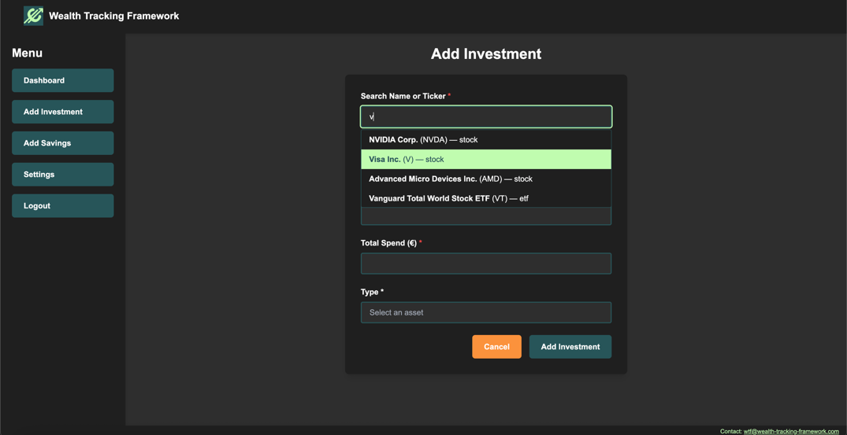

Figure 7.4.4 – Auto Fill Code

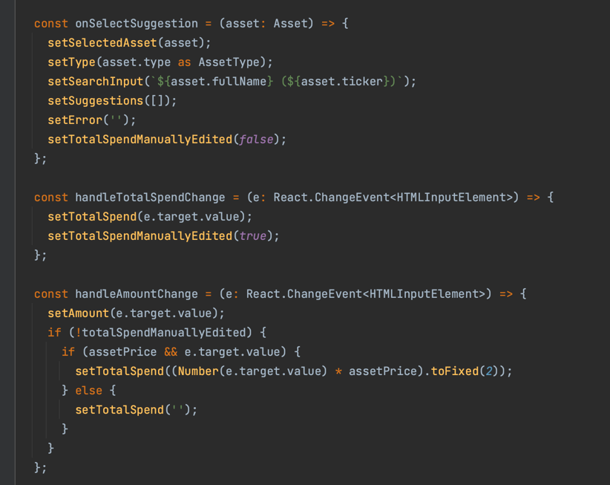

### Auto Calculate

Then after the ticker of the asset is selected the current price of that asset is grabbed from the database. The user inputs how many of the asset they want to add and then using the current price the total is calculated. The total price is editable as the price may change between platforms or have been bought at a cheaper or dearer price in the past. When the asset is selected

When the asset is selected a useEffect runs and fetches the current price from the database. The result is stored in assetPrice. A second useEffect watches assetPrice and the users inputted amount. It auto-calculates totalSpend = amount × price. The total spend can be overridden by the user if they want. The change handler on the **Total Spend** input flips a totalSpendManuallyEdited flag so the app stops overwriting the user’s number.

Figure 7.4.5 – Add Investment

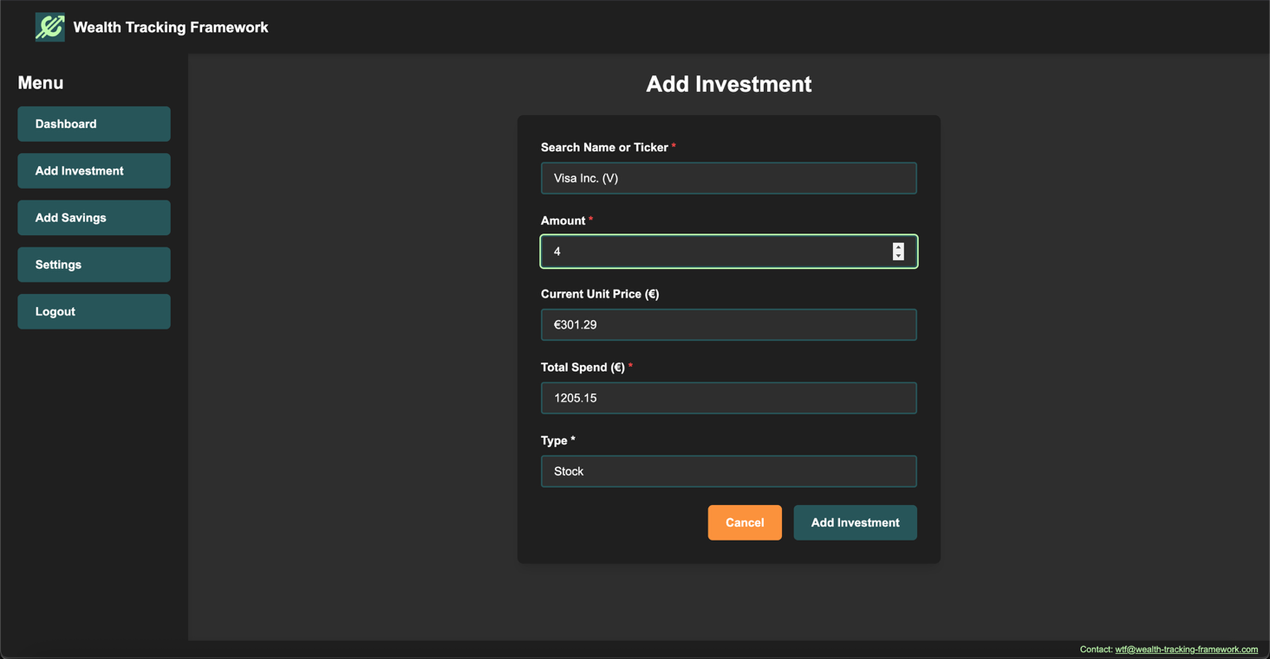

Figure 7.4.6 – useEffect for current price 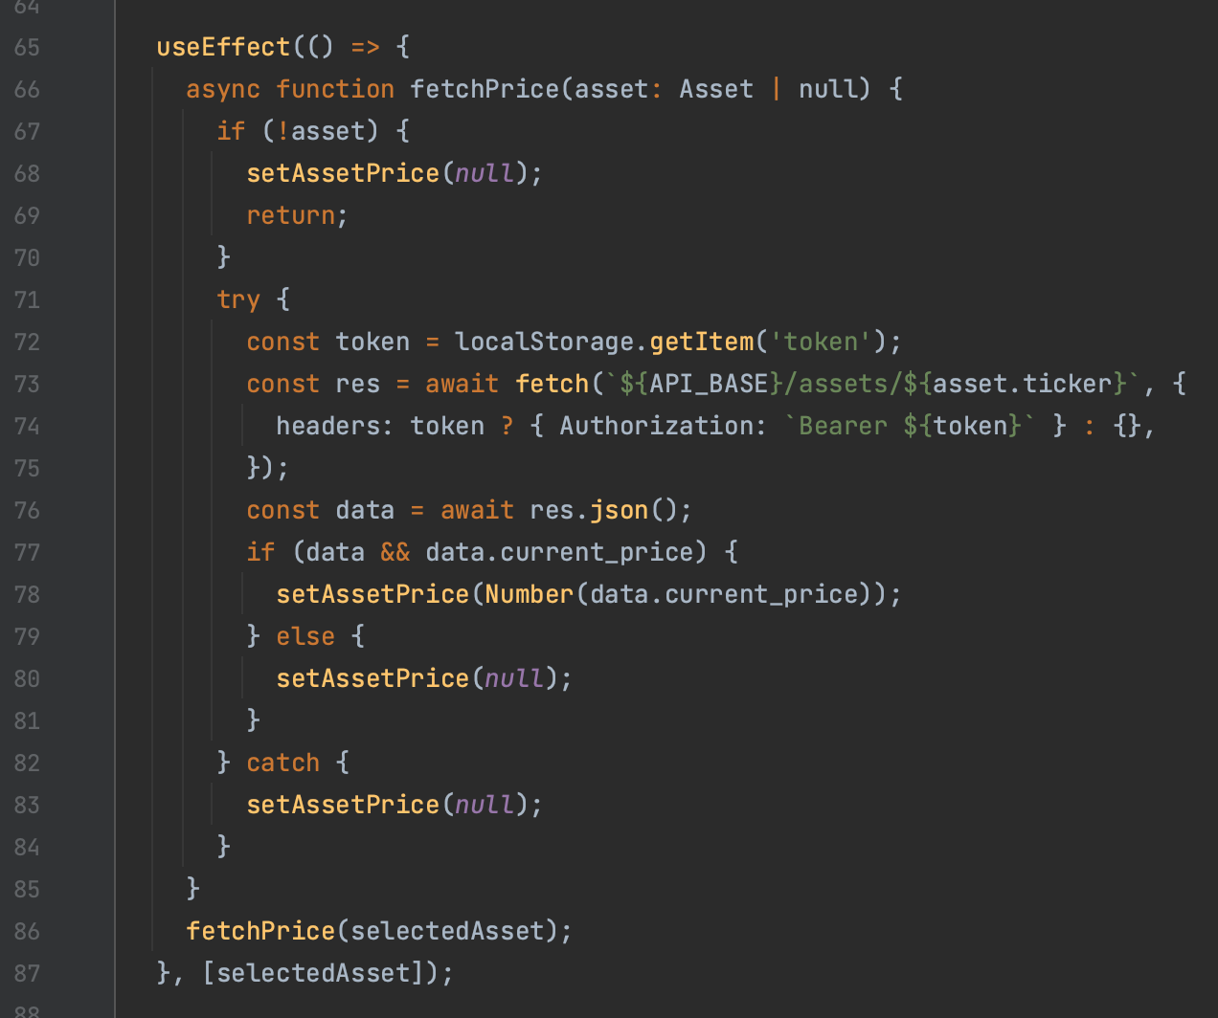

Figure 7.4.7 – Auto Calculator

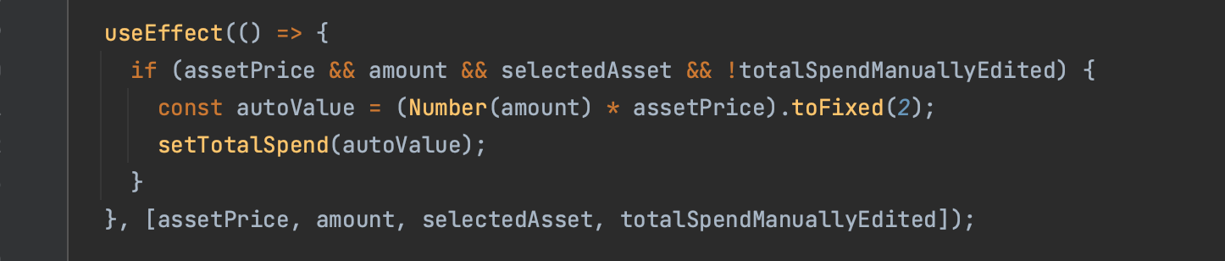

### Buy and Sell Mode

To make the files more efficient and not to repeat code the AddInvestment form has a buy and a sell mode. In sell mode the form loads the user’s holdings and only allows assets that they own to be in the drop-down menu. It also prevents users from trying to sell more than they hold.

The amount input field is configured with a dynamic max attribute equal to the user’s balance, so the browser prevents invalid entries. This UI restriction and code-level validation ensures that a user cannot sell more than they own, while still allowing the same form to be reused for both buying and selling.

Figure 7.4.8 – Buy/Sell Mode

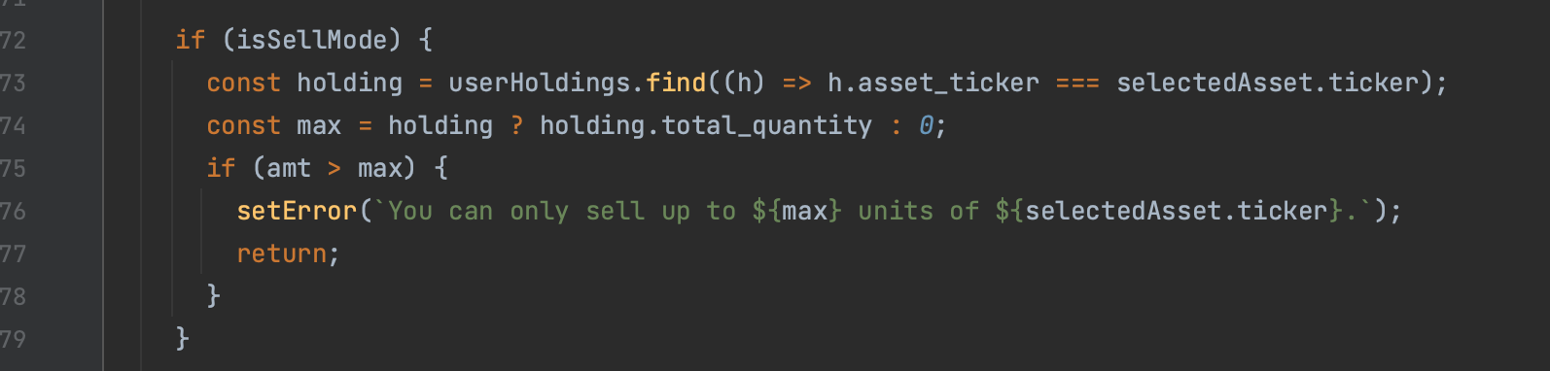 Figure 7.4.9 – Quantity Check

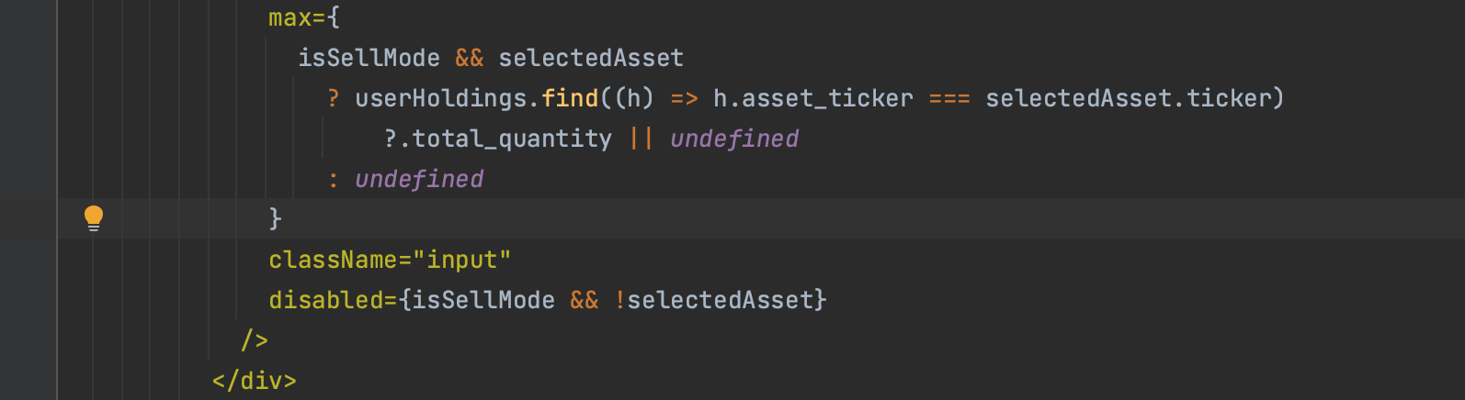

### Dashboard

After a transaction is made and the backend calculates the total holdings and updates the investment table the changes can be seen in the Dashboard showing the users total holdings. When it loads the Dashboard makes 2 API calls one to the investments table and one to the Savings table. These values are then stored and added together to show the total holdings at the top of the page. The profit and loss is also calculated using the buy prices to compare to the current value.

Figure 7.4.10 – Dashboard

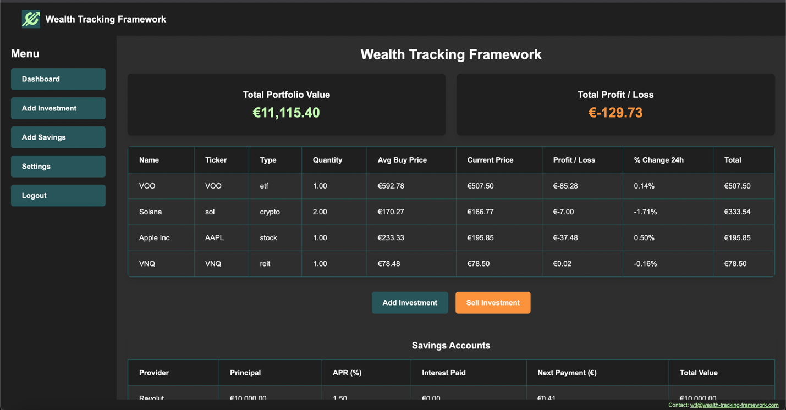

## Ansible

Ansible was chosen as the tool that would be used to simplify the setup and deployment process [13]. The other option considered was Bash scripting but Ansible offers readable YAML playbooks with clear task separation for easy debugging, a large collection of built in modules for managing packings and most importantly it contains Ansible Vault that encrypts secrets making clean up, build and deployment a one line command. The clear task driven steps can be seen in Figure 7.6 and the concise logs of the playbook running can be seen in Figure 7.7. Ansible was mostly used manually throughout the process of WTF. Initially used for extremely simple deployments locally new playbooks were added when the deployments were moved to the Hetzner server.

The playbook snippet makes it very clear what is happening with the verbose task names. Login to GitLab [20] where the images of the latest code is stored, ensuring React volume exists so it can be shared with Nginx, checking the Docker network is there so the services can talk to one another, deploy all services using Docker compose and then run the migration so the database is configured. If the database already exists the migration does nothing which is expected.

This then progressed to trying to deploy the latest application using Jenkins. in most scenarios this is not an issue but because Jenkins was running on the same server as everything else this caused issues. Jenkins was getting shut down mid pipeline from docker compose down stopping all the services. Work arounds of stopping and deleting all containers except Jenkins was failing to restart the app. When trying to separate Jenkins to a separate Docker compose file so it wouldn’t be shut down it could no longer communicate with the other services as it was no longer on the Docker network. The solution came by looking back at our previous step and using Ansible. Instead of using Jenkins to do the redeployment we made a deployment container that would run our Deployment playbook. This solved all the problems. Jenkins automatically created the container and finished its job. Ansible then ran in the wtf-deploy container shutting everything down for a few seconds and updating the application to the latest images.

### Playbooks List

* Deploy-jenkins.yml – Deploys just Jenkins on the server
* Docker-cleanup.yml – Removes all Docker elements
* Render-env.yml – Update .env file from Vault
* Setup-darwin.yml – Install prerequisites on Mac
* Setup-ubuntu.yml – Install Prerequisites on Ubuntu
* Start-on-server.yml – Deploy on server
* Start-locally.yml - Deploy on local device

Figure 7.5.1 – Ansible Tasks 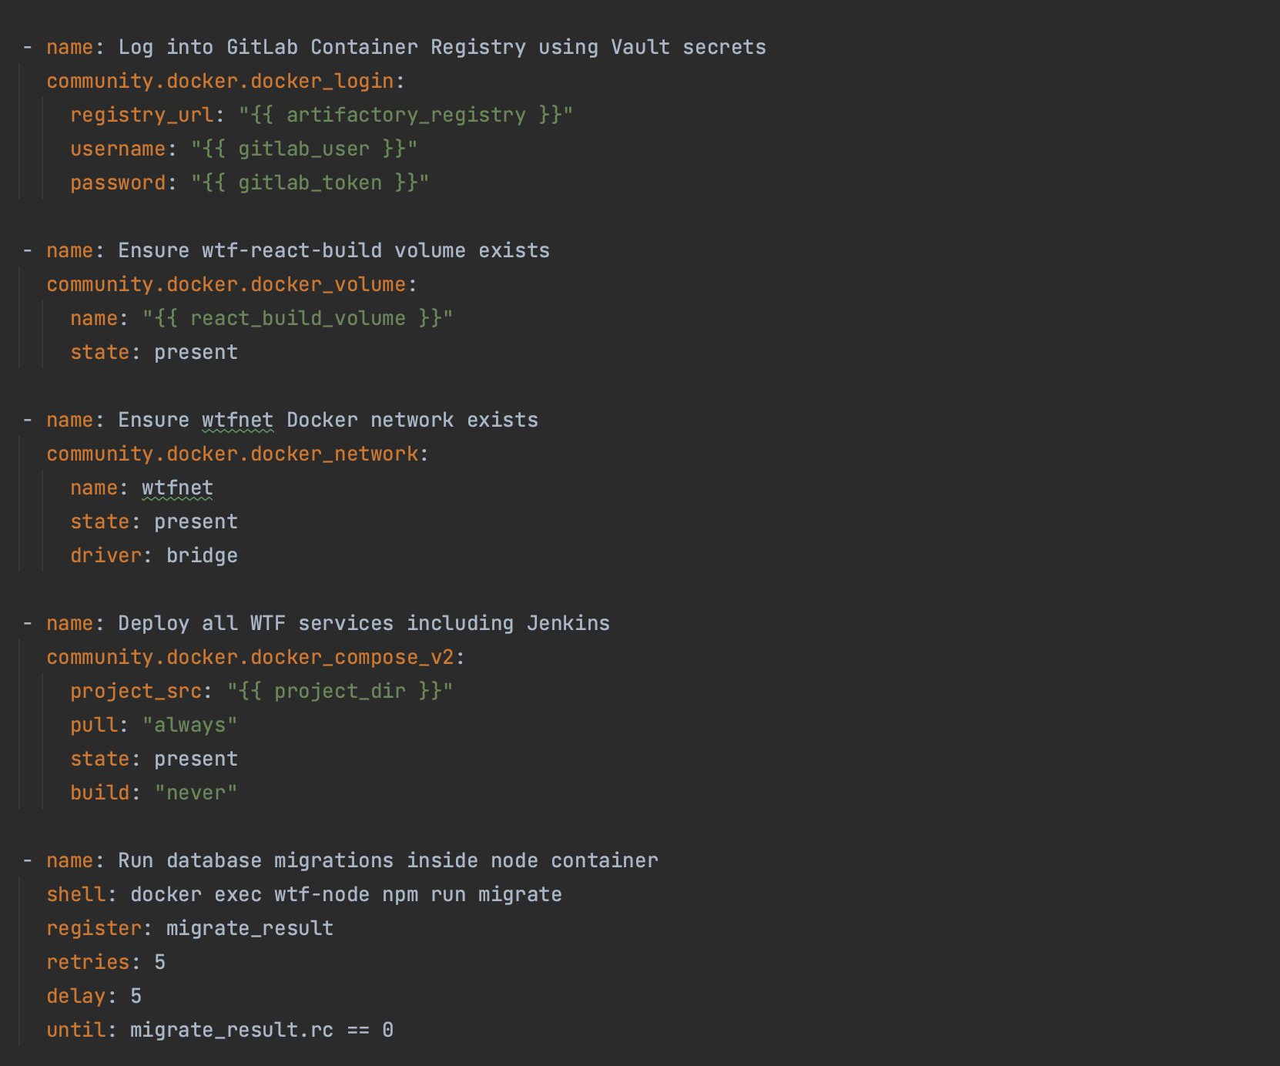

Figure 7.5.2 – Ansible Output

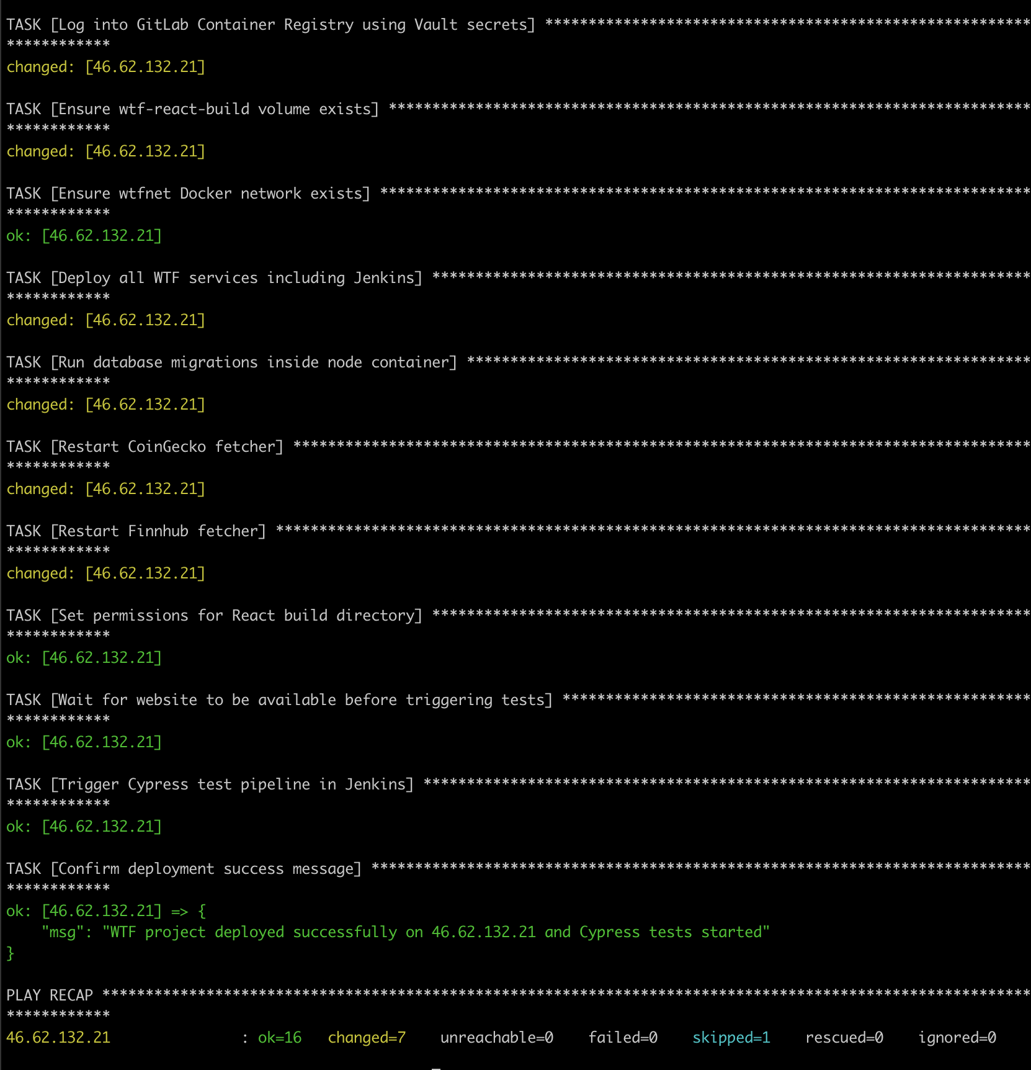

## Jenkins

Jenkins is the heartbeat of the DevOps workflow. It is a CI/CD (Continuous Integration/ Continuous Deployment) tool. The initial plan was to use Jenkins as the tool that would run the Cypress tests but that expanded to help reduce the steps needed for making updates to WTF. The only other automation server considered was GitLab [20] CI but due to some previous experience using Jenkins pipelines but not having created pipelines it was the better choice.

### CI/CD

Figure 7.6.1 shows the CI/CD flow. It’s four pipelines that run automatically starting with the build pipeline which when finished starts the next pipeline.

Figure 7.6.1 – CI/CD Workflow

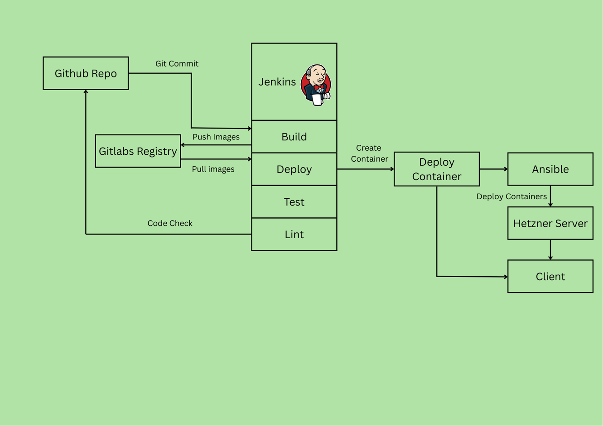

#### Build and Push

The CI/CD flow starts after a Git commit is pushed to the repository. A Git hook triggers the first pipeline which is build and push. Basically this builds all the services in the Docker Compose file, which for networking issues is all services. The images are then pushed to the GitLab Container Registry, which required less configuration than GitHub’s registry so was far easier to integrate and was free to use, unlike JFrog Artifactory which is not free but is a universal repository and is common in Industry. The images are not saved locally after being created in the Jenkins Docker environment [12].

The Build and Push stage basically runs the 2 commands docker build which builds the images that we have listed that have custom docker files followed by docker push the image to the registry (Figure 7.6.1)

Figure 7.6.2– Build and Push Stage

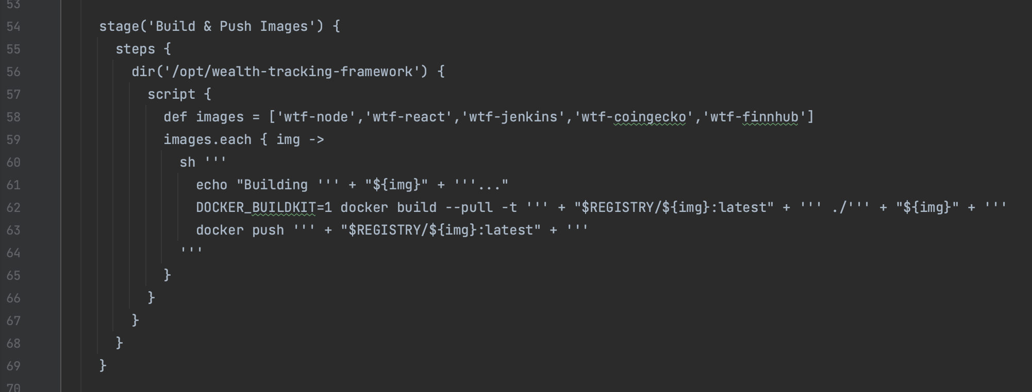

#### Deploy

Once the images are built the build pipeline starts the deployment pipeline. This should have been easy, docker compose down followed by pulling the latest images and docker compose up. This would work but Jenkins is running on the same server as the app stack. This means docker compose down stops Jenkins from running causing the job to stop in the middle of trying to deploy. One solution would be to run Jenkins in its own server as standard but for WTF this is not cost effective or necessary. Stopping and removing was the first attempt at resolving the issue. This did not work as while images were stopped they could not be removed due to the React volume still technically in use. Trying to remove the volume and serve the files directly to Nginx did not work so a different solution was needed. As the Ansible playbook was used to deploy manually a simple Jenkins job was created.

Create a container that calls the deployment playbook. This had the issue of not being able to pass the Vault password but adding a script that could get the details from the .env file provided the final solution. The final deployment pipeline removes the old deployment container if it exists, builds the image of the wtf-deploy container which is in its own Docker Compose file, it creates that container, cleans up and exits. The pipeline does not wait for the container to run and the job is successful if the container is created. The container has a small delay so as not to overlap with the deployment pipeline. It then runs the Ansible playbook that does the full deployment with all services shutting down, images updating and deploying to the server. This is unaffected by the shutdown allowing a fully automated deployment.

The deployment stage is quite simple just the one command that is docker run which creates the wtf-deploy container (Figure 7.6.3). The container starts a script (Figure 7.6.4). This is because the Vault password must be saved in a text file for the Ansible playbook to be ran. The script then goes on to run the deployment playbook (Figure 7.6.1). It ensures the password exists and then cleans up after

Figure 7.6.3 – Deploy Stage

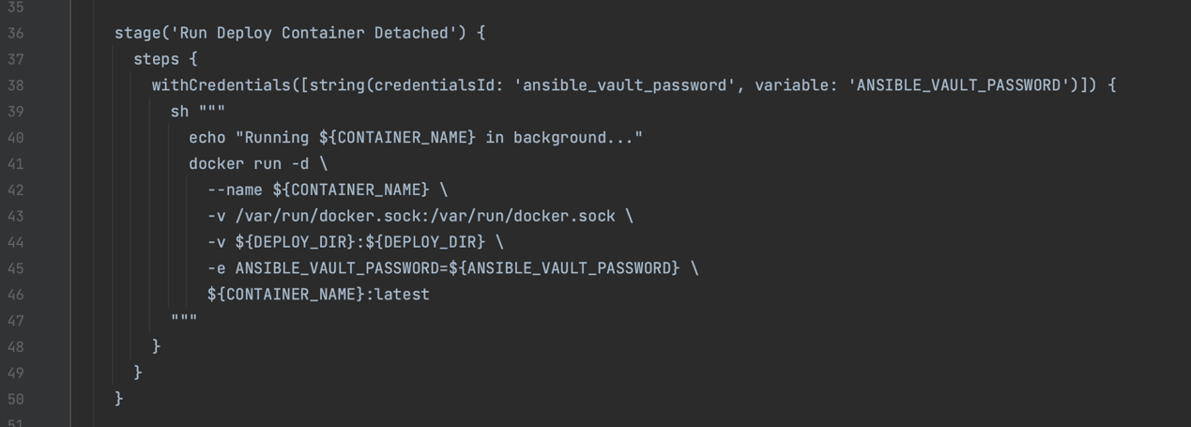

Figure 7.6.4 – Vault Secret Script

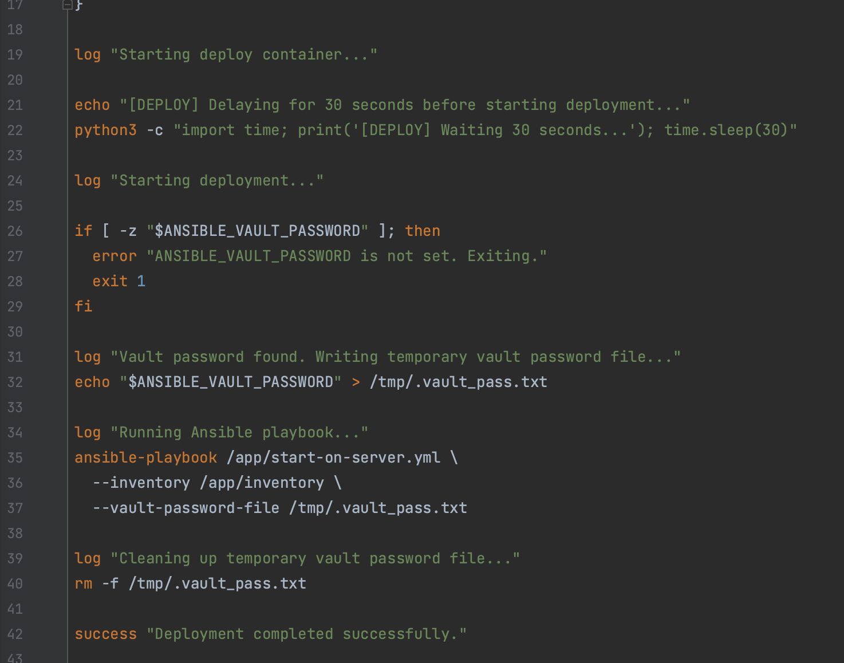

#### Test and Lint

As Jenkins is shutdown the pipeline was unable to add a stage to kick off testing. Instead a task was added to the playbook that kicks off the test pipeline that runs the Cypress e2e tests. This in turn starts the linting pipeline. In industry any failures would open a defect in Jira but as Jira was not integrated in WTF the same idea was implemented using GitHub’s API is used to create issues on test and linting failures. This ensures any errors are tracked and visible making it easier to see if changes to the code break any core features.

The Cypress e2e test stage runs the Cypress tests inside a disposable container (Figure 7.6.5). It mounts data into the workspace for Allure [14] and CI to get them when the container exits. The step is wrapped in catchError(... 'UNSTABLE') so that on test failure the pipeline still completes so other stages can complete as test failures are not a pipeline issue.

Figure 7.6.5 – Run e2e Test Stage

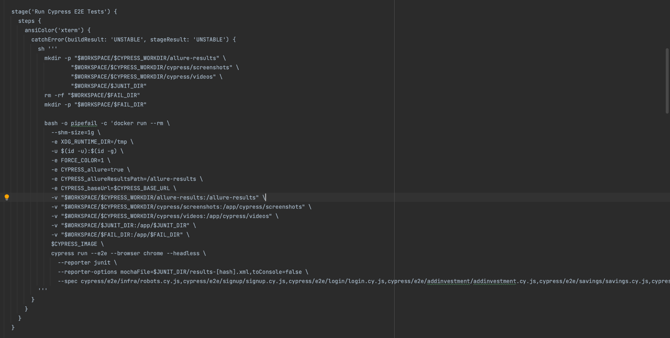

During the testing pipeline the Create ticket on failure stage (Figure 7.6.6) opens an issue on GitHub when the Cypress tests fail so the build is UNSTABLE. It gets the secure GH_TOKEN from credentials stored in Jenkins adds vital details with the build URL and commit and uses httpRequest and POSTS to the repos Issues API (Figure 7.6.7), so any failures become tickets [21].

Figure 7.6.6 – Create Ticket Stage

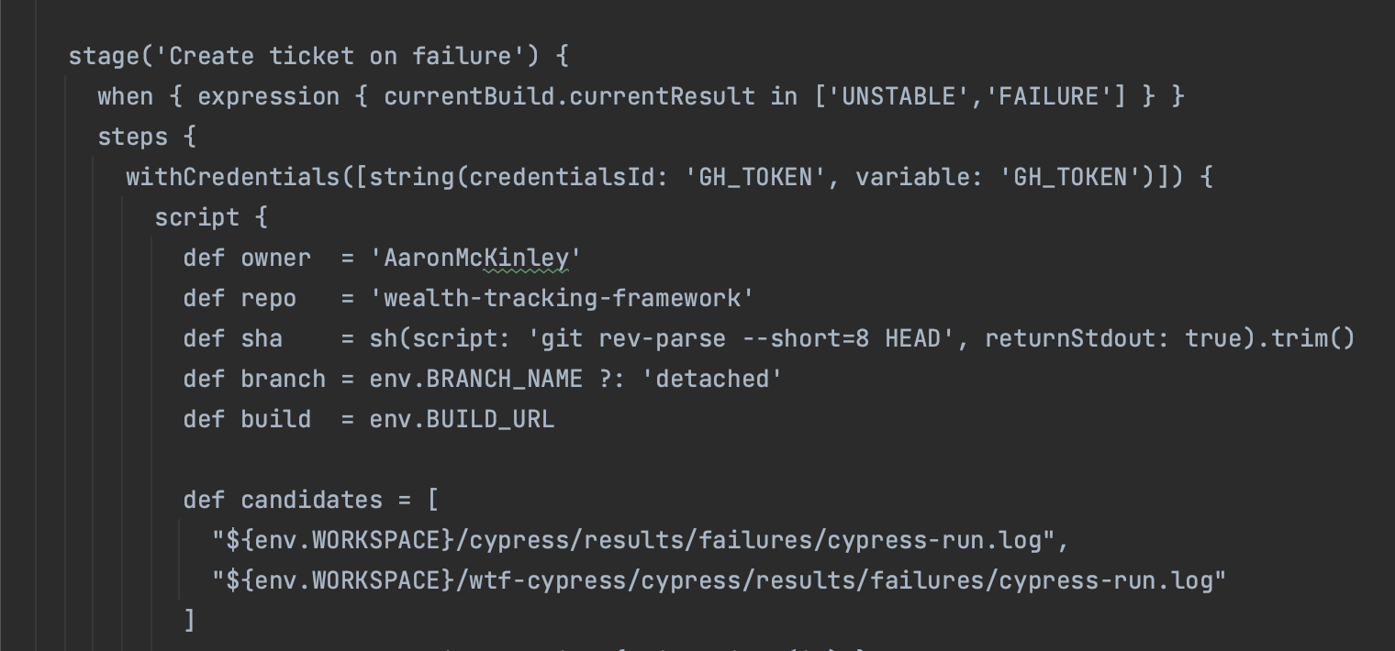

Figure 7.6.7 – GitHub API

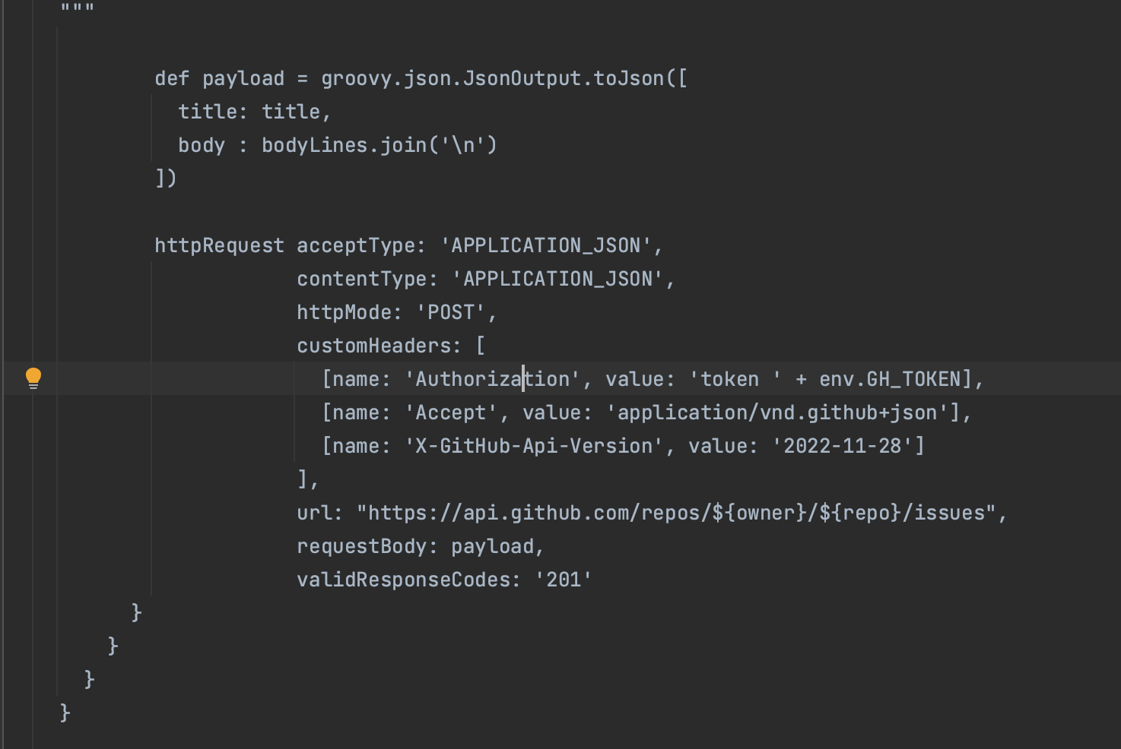

Figure 7.6.8 shows the output from the build pipeline. It is a good example as the Docker build is running copying the package-json and installing dependencies followed by the docker push beginning to push the image layers to the GitLabs image registry.

Figure 7.6.8 – Jenkins Build Output

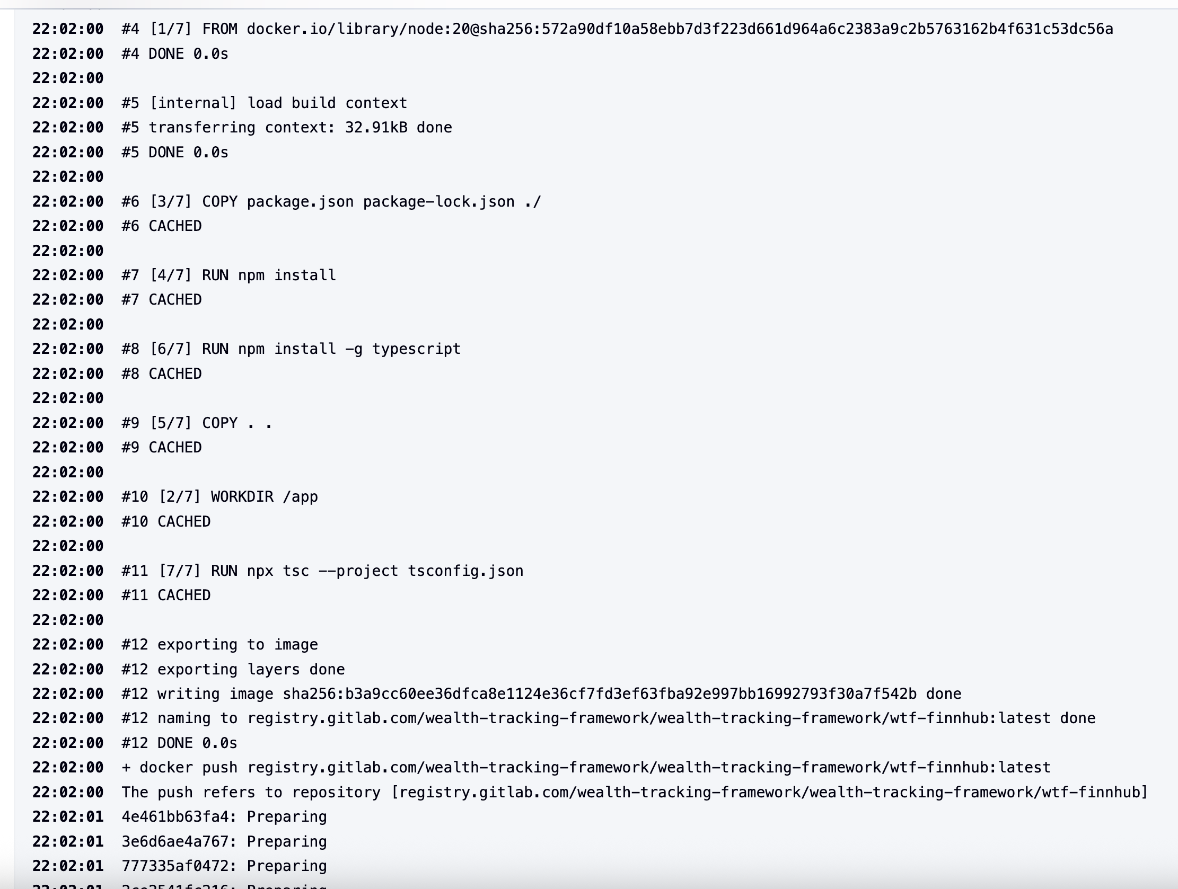

## Fetchers

The Fetchers consist of two custom containers each using an API to get financial data from both stocks and cryptocurrencies. CoinGecko is used for cryptocurrencies the free tier offers thirty API requests a minute and 10,000 a month. Only on call is needed to get all required assets information [5]. The CoinGecko fetcher the Dockerfile can be seen at (Figure7.7.2). The file copies the Fetcher script files installs dependencies and then the CMD runs the bash command that runs every 600 seconds or every 5 minutes. This keeps the Fetcher with in the API limits. This means the fetcher makes 288 API requests a day or 8.6k-8.9k requests a month.

Finnhub is used for the stocks, it has not got a monthly limit but is limited to 30 requests a minute [10]. Each asset also requires two requests per asset one for financial data and one for name, currency and type. WTF currently has 60 stocks available and that is split into three segments of twenty that updates every two minutes. The Fetchers then upsert this data to PostgreSQL so it is constantly updated. This means that any one asset is updated every six minutes as the Fetcher cycles through the stocks.

The Finnhub and CoinGecko both upsert the data to the database. Finnhub requires a bit more work due to its limitations per minute. Figure 7.7.1 shows how an array is made and that is then used to split the 120 requests needed to add the stock data. It is split into 2 minute intervals

Figure 7.7.1–Finnhub Chunk-Array

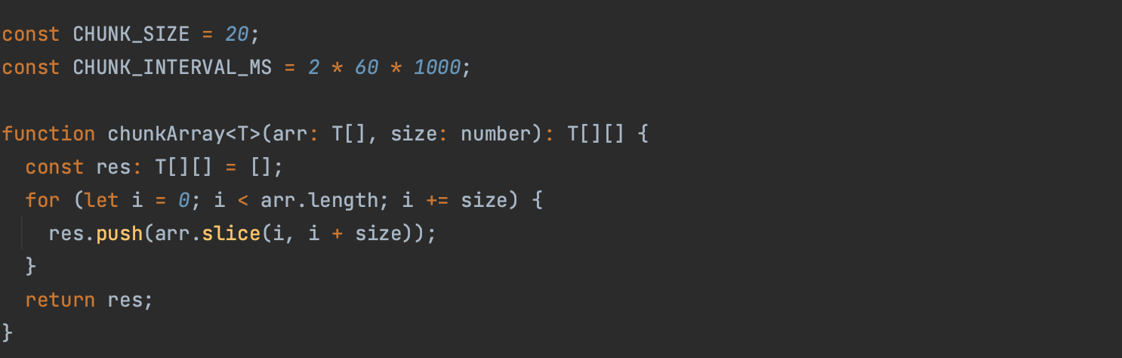

The main () function (Figure7.7.2) acts a process scheduler. It loops forever records the current chunk waits for the upsert fetchAndUpsertChunk and moves on to the next chunk. This is what keeps each stock updated every 6 minutes.

Figure 7.7.2–USD conversion

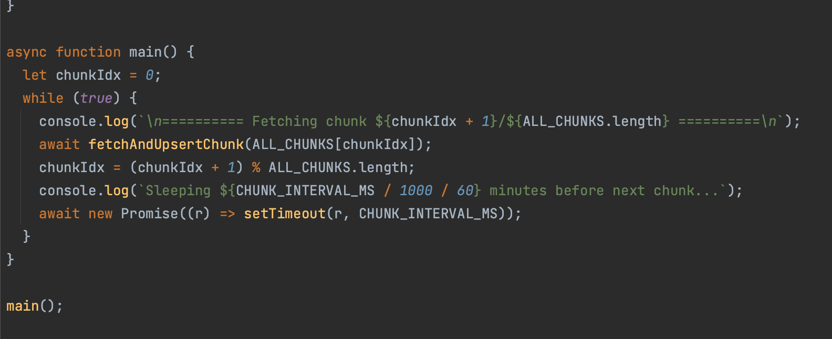

If the limits are exceeded the API providers return a HTTP 429 error for too many requests. If this happens its logged by the fetcher and can be seen in the container logs. These limitations can be removed by paid versions of the APIs but for the purposes of WTF as a wealth tracker accuracy with 5-6 minutes is sufficient. Figure 7.7.3 shows the CoinGecko Dockerfile that copies the coin lists, installs dependencies and sets the container to sleep for 600s or 5 minutes before running again

Figure 7.7.3–CoinGecko Dockerfile

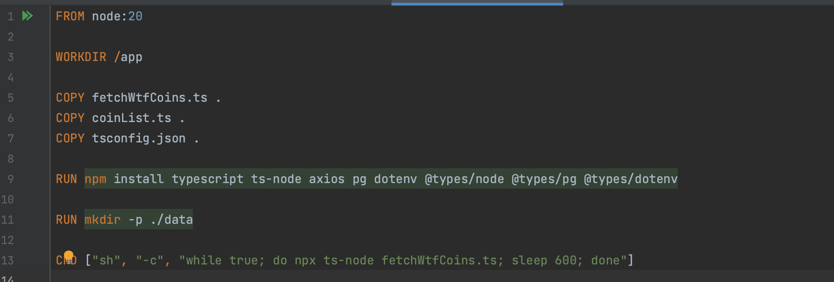

The function getUSDToEurRate uses the frankfurter API which is free to convert the stock prices to Euros. It reads rates.Eur from the response and adds that data is later added to the database. If the call fails it returns a fallback of 1 so the fetcher still runs but uses USD prices

Figure 7.7.4–Currency Conversion

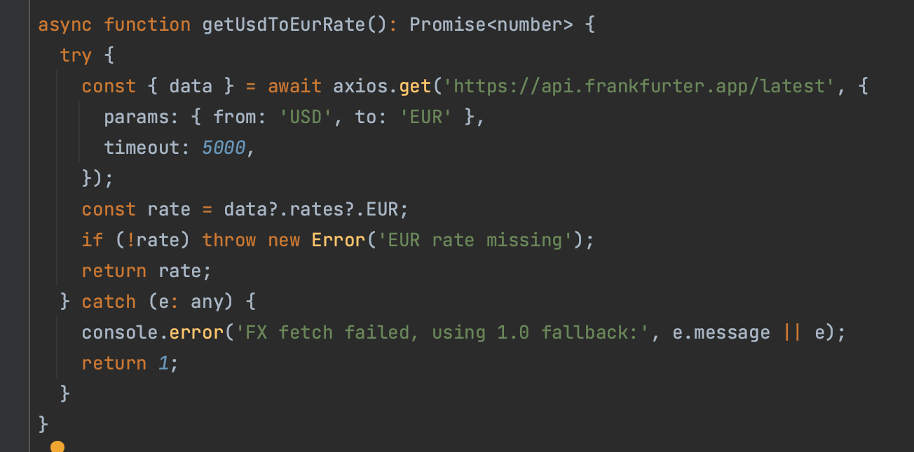

Figure 7.7.5 shows the code that upserts the data from the fetcher into the database. It runs at intervals 5 minutes for CoinGecko and in 2 minute chunks for Finnhub. The Fetcher first tries to create a row from the asset ticker which its unique code and if there is a conflict it attempts to update instead.

Figure 7.7.5–Finnhub Upsert

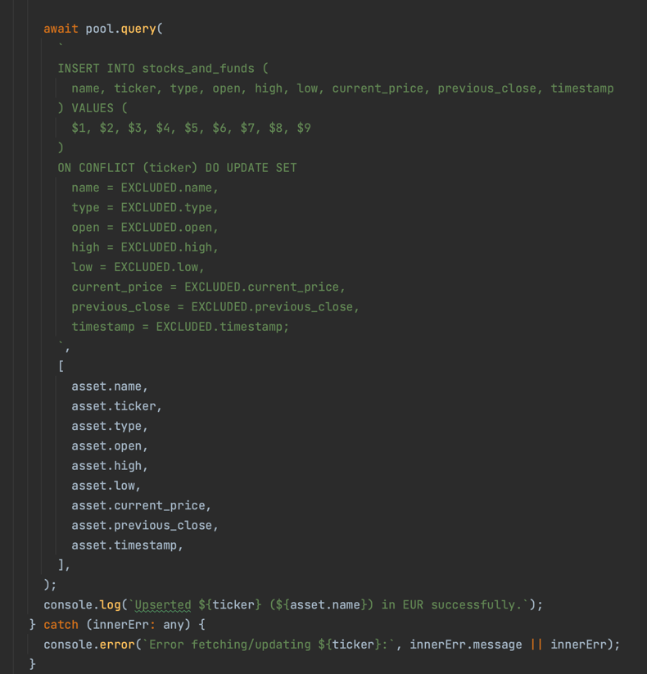

## Cypress

Cypress was chosen due to the fact at the start of the development of WTF I had just changed roles in work to an Automation Engineer and had begun working with Cypress tests. It is used to replicate end user actions. WTF has a suite of 20 tests that run as an end to end flow (e2e). The tests check robots.txt is being served first. Robots.txt is used by search engines to see what parts of the website should be excluded from search engines for WTF that’s any backend routes /api/* and Jenkins.Wealth-Tracking-Framework.com.

The tests then move on to a specific flow that leaves no trace once the tests are completed. The order is specified by Jenkins but the tests can work by running locally. Cypress checks the homepage works it then goes on to create a new user in the sign up page. It the checks Login by logging in as this user. It checks all elements sidebar header footer work on various pages. It goes on to test the buying and selling of assets before deleting the user that was created completing the e2e flow and leaving no trace.

Each Cypress test has a cy.js file that has 2 specific helper files. All specific functions are written in the support/actions.js and locators contains the HTML elements that Cypress uses to navigate the web app. Any common functions are in the helpers/actions.js(Figure 7.10) [11].

Figure 7.10.1–Cypress Structure

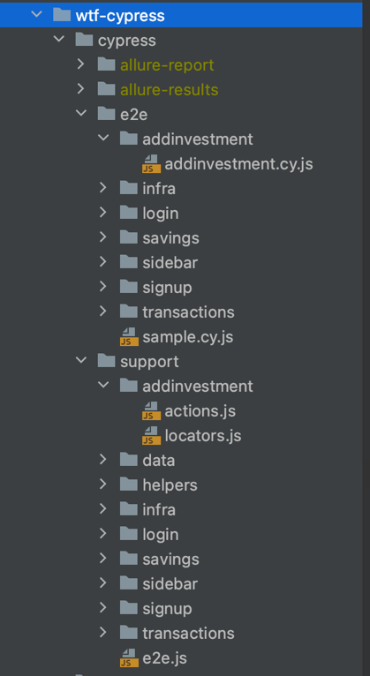

The Cypress config file (Figure 7.10.2) defines how the e2e tests run. It uses the base URL or localhost. It specifies where to find the cy.js files as well as the support files. The setUpNodeFunction is configuration for Allure which should save the output of the results to allure-results.

Figure 7.10.2–Cypress Config

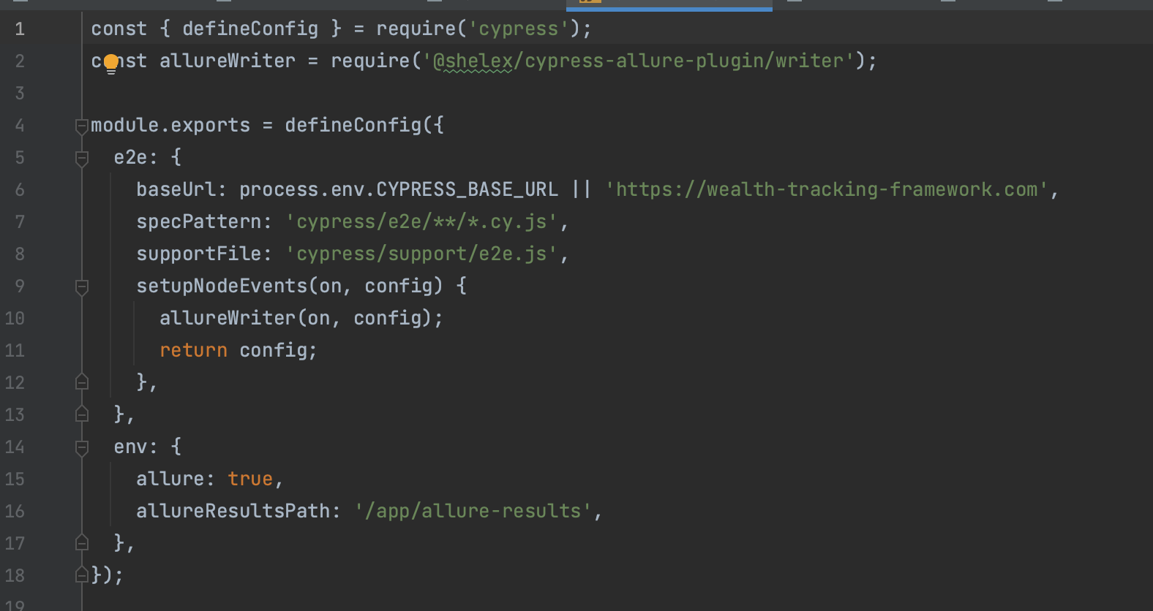

### Locators

The Helper locator file (Figure 7.12) is a good example of how the locators work. The element needed for a test are stored as a verbose name. For example the Submit button is given a name submitBtn which then associated with a button element that contains “Submit”. This can be then called later by using the name you import them as like SEL.container

Figure 7.10.3–Helper-Locators

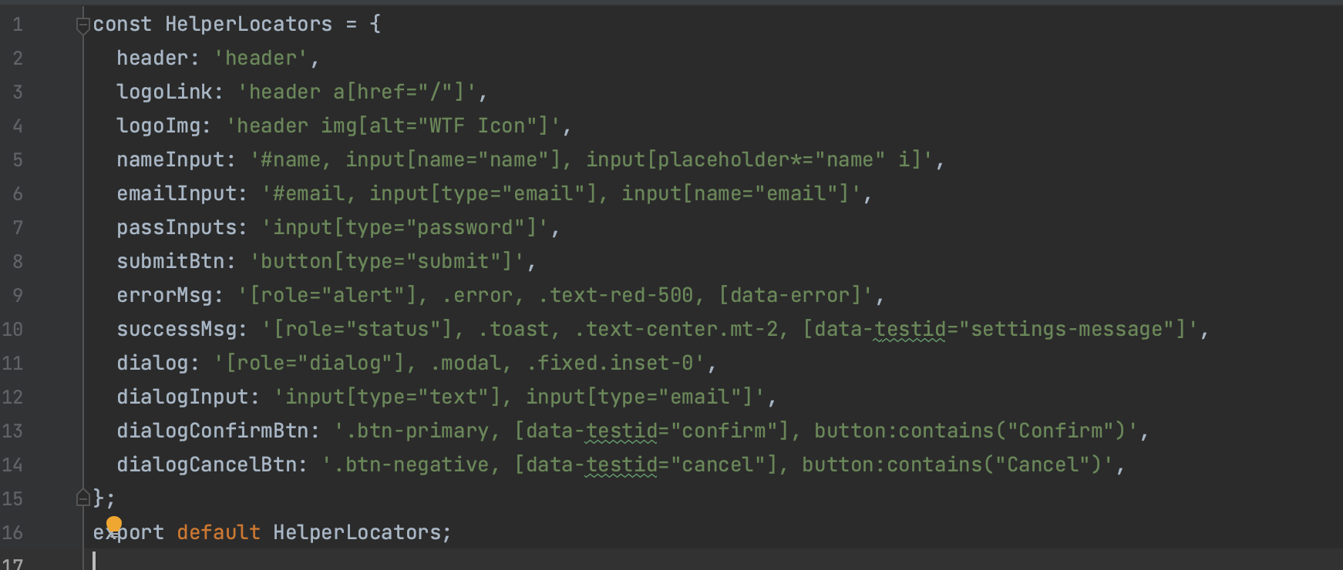

### Spec and Actions

Spec files are the actual tests that run (Figure 7.10.4) They designed to be as verbose as possible with all logic kept to the action files (Figure 7.10.6) they start with a describe (Figure 7.10.5which gives the general outline of the test run and then each iteration that is started by an it(‘does a test’) is considered a test in the test run. It has a before which ensures login and a before each which double checks the login is still valid. It then moves on to our it statements. For the sidebar tests they are quite basic it’s a simple navigation check moving from button to button ensuring that we move to a new page. Sidebar.gotoInvestments is quite clear. The actions page(Figure 7.10.6 defines the gotoInvestments and checks the URL is correct that we have moved to.

Figure 7.10.4–Sidebar Spec It statements

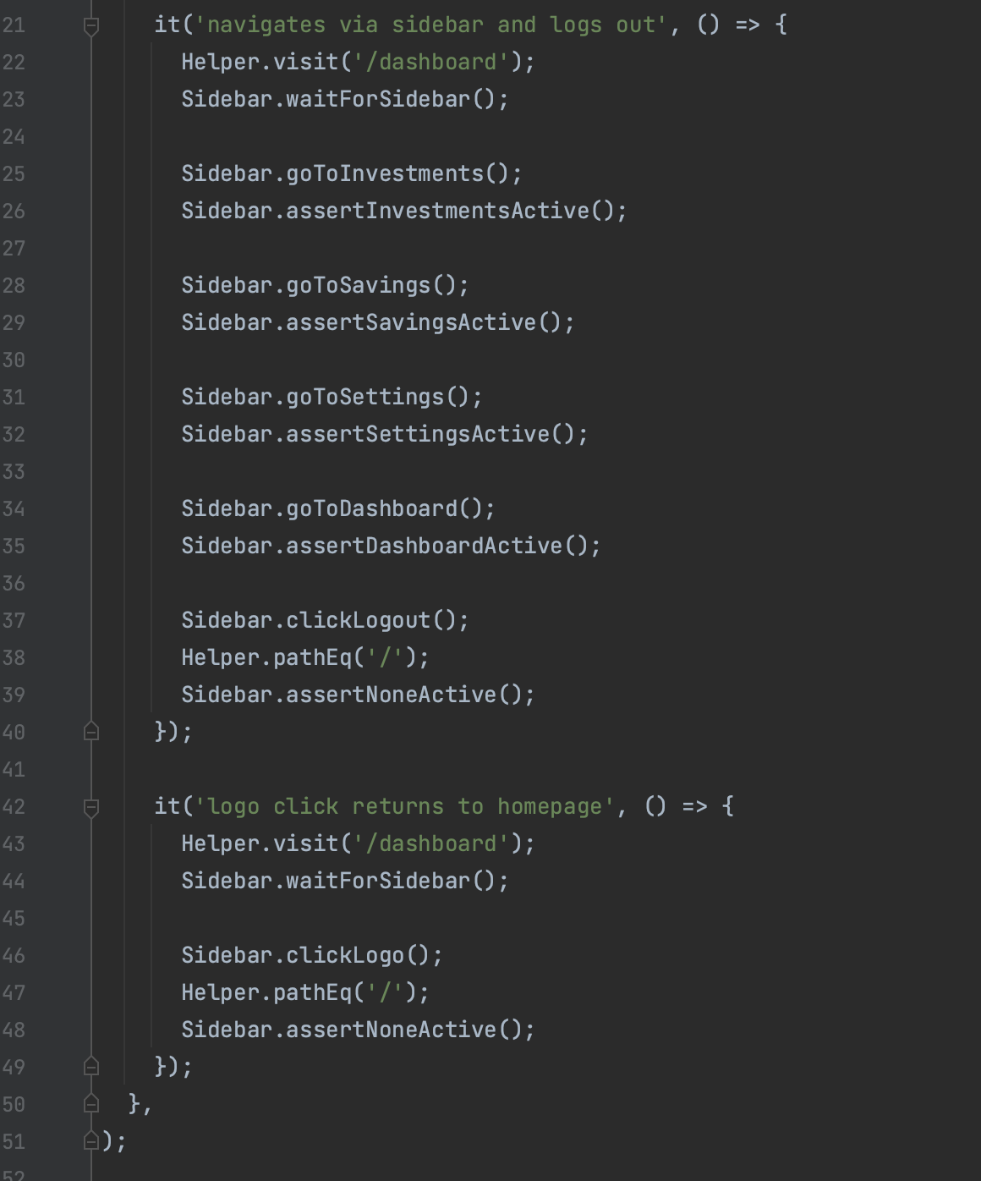

Figure 7.10.5–Sidebar Spec Describe

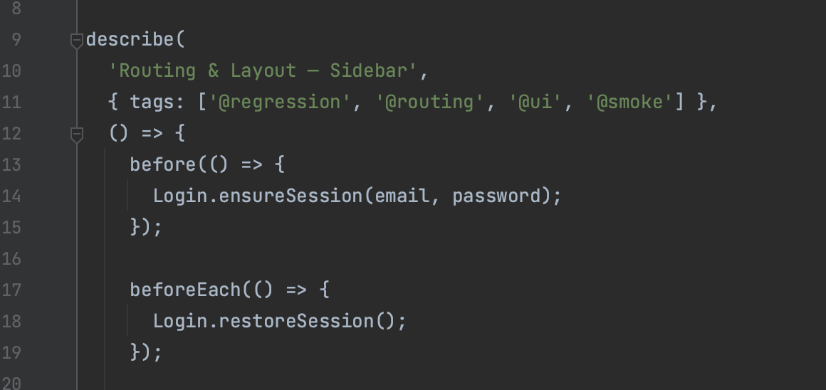

Figure 7.10.6–Sidebar Actions

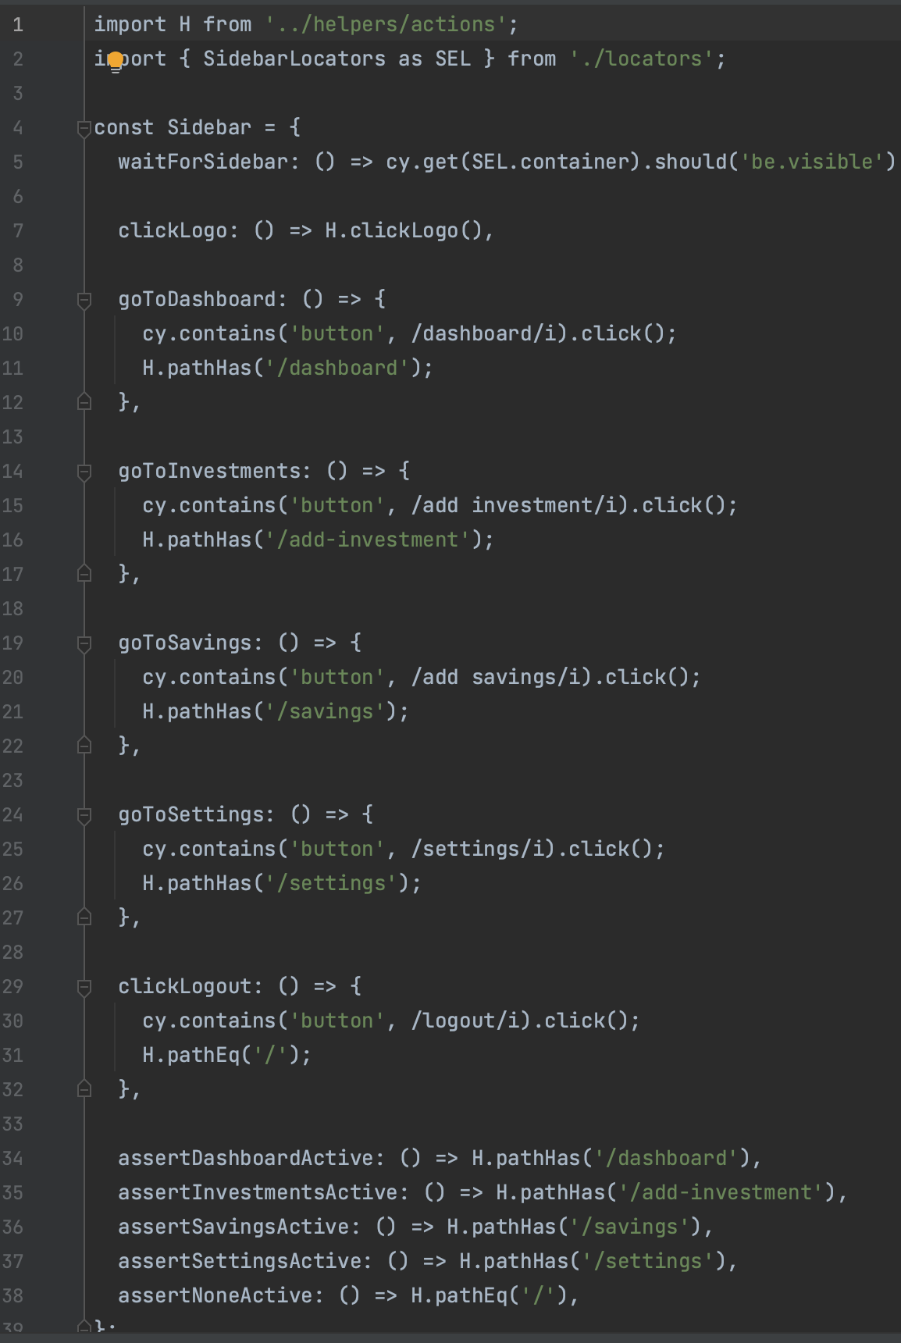

### Results Output

Here is the example of the output from the cypress tests in Jenkins. Each spec file runs outputting passes and failures and at the end we get an overview of the tests.

Figure 7.10.7–Sidebar Test Output

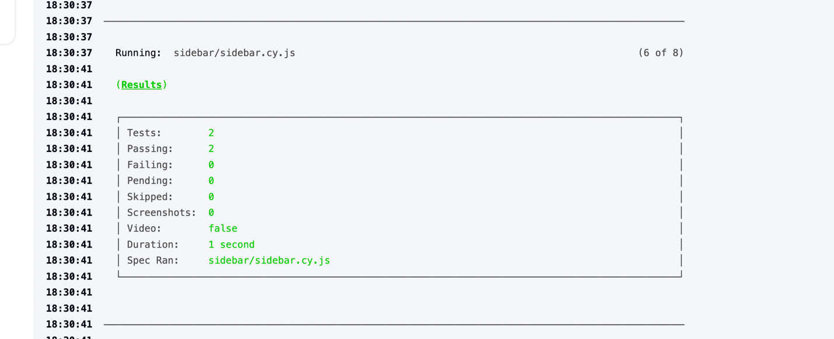

Figure 7.10.8–Cypress Test Run

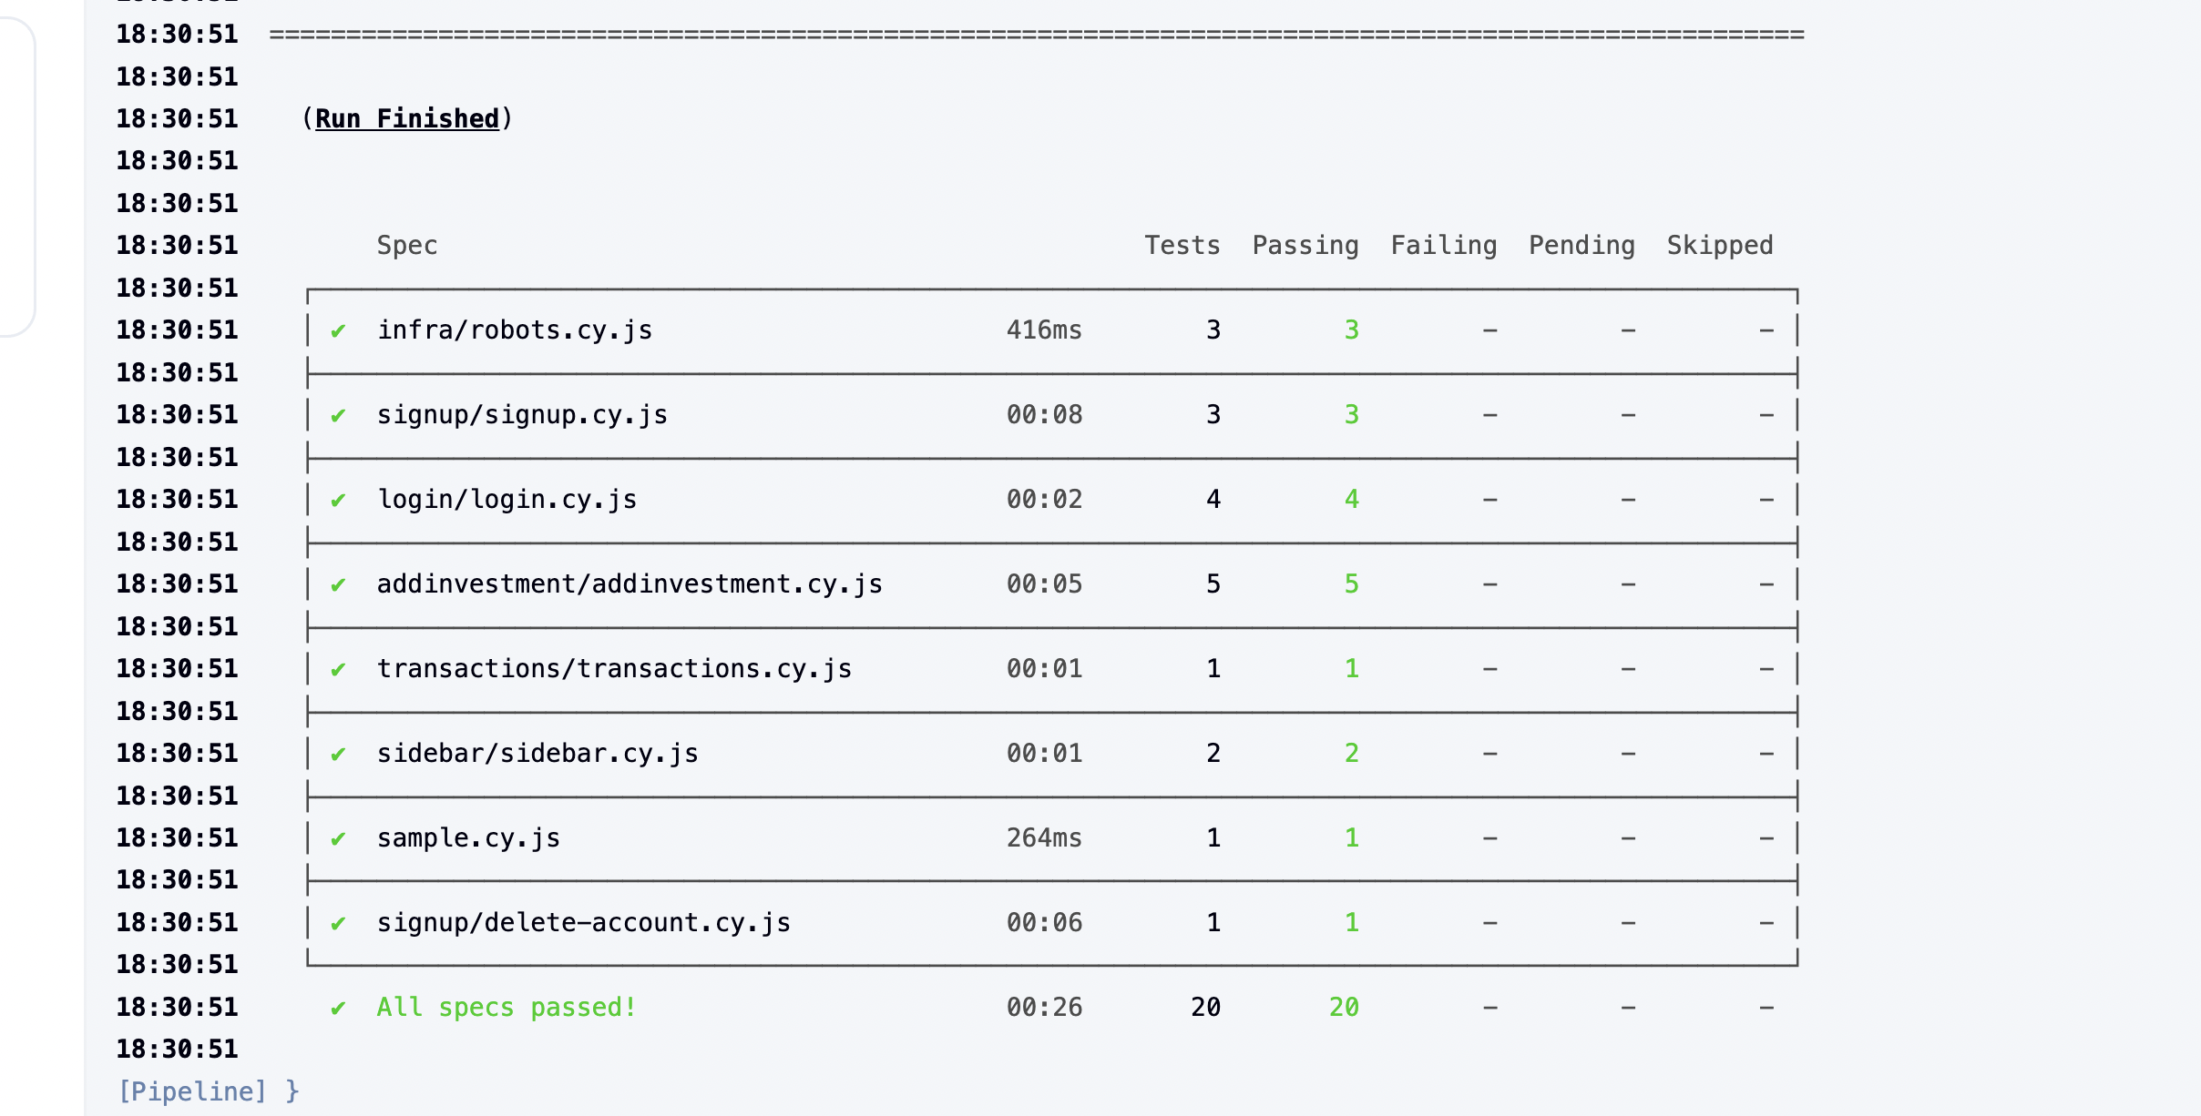

## Nginx

Nginx is the most common reverse proxy used in industry. It’s used so only expose one port rather than each service needing its own this means it redirects requests to the correct place It is also a load balancer handling static files instead of a live React container saving memory. Using it in WTF would simplify routing and provide a production style setup like modern deployments [6].

### Nginx Deployment and Issues

Nginx was not an original part of the architecture. It was added after deploying onto the server and access to was needed. Instead of attempting to do all the individual routes to expose Nginx is used which adds to security as only one port is exposed. This caused its own issues as while this saves on server memory updating the static files caused a lot of issues. Attempting to mount the files in the Nginx container like all mounting in this project caused its own headache but once a change was made and redeploy done the updates were not visible. This was because the static files were not being updated as they already exist. This led to the decision to remove the React volume and completely clean down Nginx and React each deployment. While unorthodox and Jenkins needed its own workaround it provided a consistent deployment flow and ensured the UI was always up to date.

### Nginx Proxys

Nginx hides all the ports used by the services so that when a user hits an endpoint it can redirect it to the right container this means that that the internal containers and ports are hidden from the public. It also redirects URLs so that www. Is not always needed when attempting to get to the application. Certbot [15] is a free and commonly used certificate authority. It was used to set up the TLS certs which encrypt all traffic between clients connecting to the server. The certs are then automated by creating a Certbot container that renews expired TLS certs this means that WTF uses HTTPS instead of HTTP making it more secure

### Nginx Proxy Jenkins Example

This configuration in Figure 7.9.1 shows how Jenkins is exposed securely over HTTPS using NGINX and Certbot. Certbot provides the TLS certificates which NGINX references as ssl_certificate and ssl_certificate_key*.* When a client connects to Jenkins at Jenkins.Wealth-Tracking-Framework.com Nginx ensures all traffic between the server and client uses these certs to make the session encrypted. The request is then proxied to the Jenkins container internally on port 8080 using the Docker network. The headers X-Real-IP and X-Forwarded-For are used so Jenkins knows the original client I.P. and Strict-Transport-Security enforces the use of HTTPS for all future connections. This means Jenkins can remain hidden behind NGINX with only the secure public endpoint exposed.

Figure 7.9.1–Nginx Flow

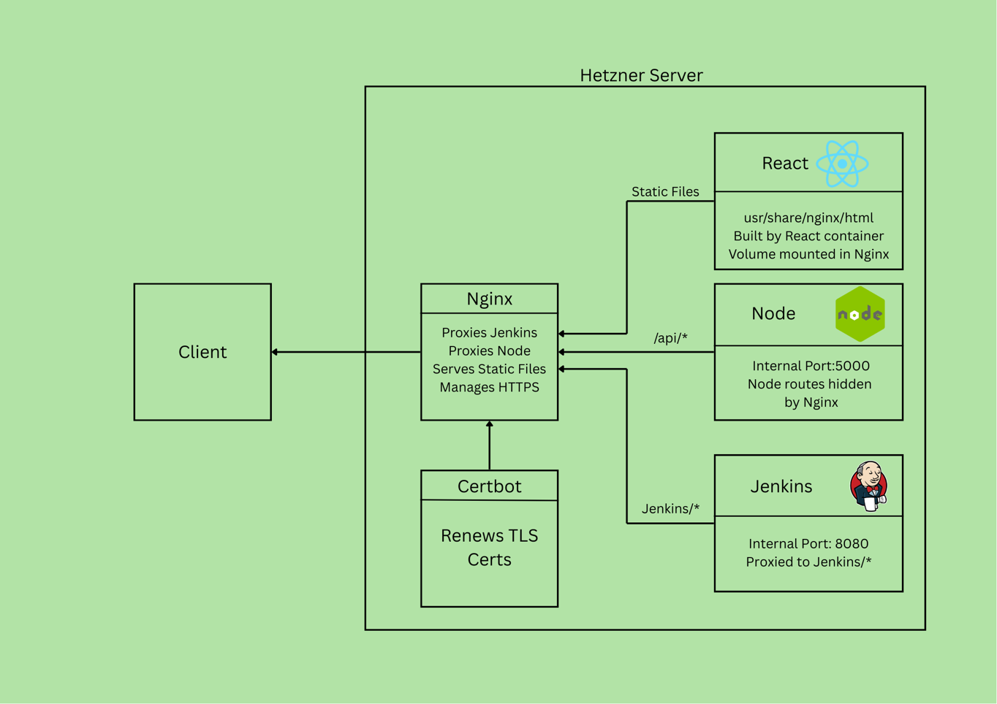

Figure 7.9.2–Jenkins Proxy

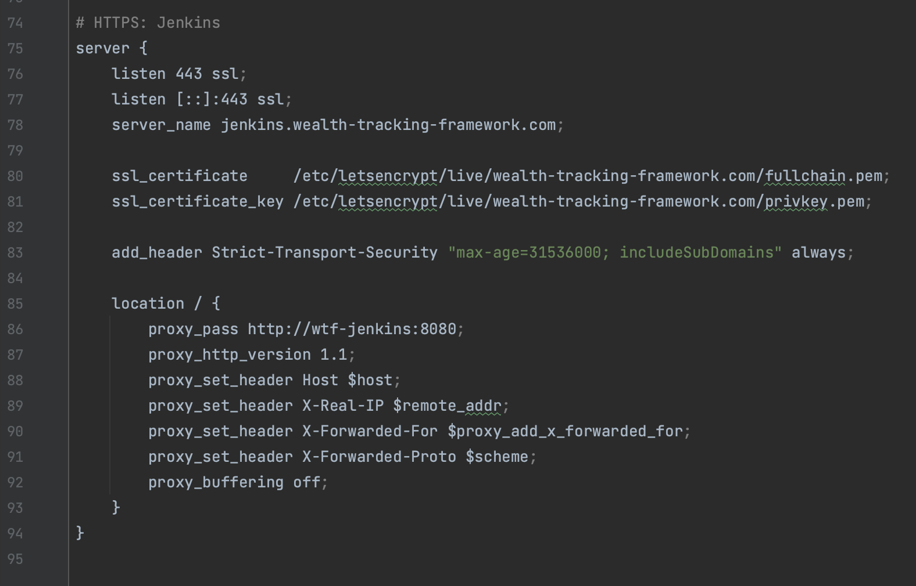

## Allure

With the CI/CD workflow working and the Cypress e2e tests passing the final step of the plan was to be able to view the results in the Allure GUI giving percentages of tests passed and Allures menu to show any failures along with screenshots and recordings of where the error occurred. This feature did not quite get integrated fully. While it worked when testing locally after moving to the Hetzner server and getting the tests running the allure-results files are not getting mounted properly. The tests run and the volume of results from the temporary Cypress container should be mounted to the Jenkins container so the results can be displayed. After changing the mount, the Cypress config, the working directory, the Cypress folder structure and the results directory the issue of no files being mounted persists. While Allure is integrated properly as it worked while running locally, though there was mounting issues there too, and the Allure report is available on Jenkins the results are not showing up in it. With more development this will be the next step to complete. Figure 7.6.5 in the Jenkins section shows how many files need to be mounted in a complex arrangement and with a small adjustment the allure results should be visible.

Figure 7.10.1–Allure Report Stage

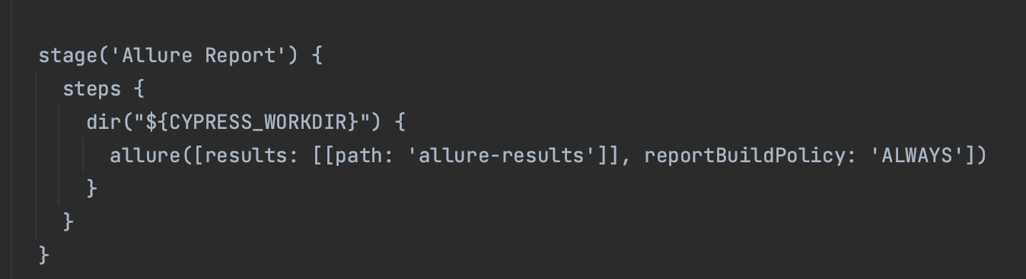

## Hetzner Server.

To host the WTF application the original plan was to use OpenShift [22] which is an enterprise level tool that offers 1GB free. For the cheapest tier bigger than that was $50 and was very much overkill. The next option was to run an OpenShift server on a dedicated computer and while cost efficient is not the most practical as it would require more maintenance starting up fresh each time the computer is turned back on which has to be done manually the first time.

Looking for a different provider after OpenShift which did not provide the memory needed and was too unwieldy for a web application like WTF the first option explored was Azure. There are free student credits but if they ran out the price would be around €128 a month for 16GB RAM. AWS was no better at €111 for 16GB RAM. Looking for a cheaper alternative Hetzner offers shared vCPUs [23]. This means that the physical CPU cores are shared with other VMs but the 32GB AMD server was coming it at €16.11 a month a much more affordable rate. It is also a flat rate so if more memory is used that paid for there is no unexpected charges. Hetzner offers a far simpler solution being a simple Ubuntu console VM that was perfect for WTFs needs.

Having set up WTF on Hetzner and left it running while developing the memory capacity which stopped the containers from being deployed. This was because the Jenkins pipeline that pulled images was keeping all the images permanently as well as all the old Jenkins builds even though in the Jenkins configuration it was set to just keep the last 10 builds it still kept the old builds in the Jenkins volume. This was an expected issue but adding a clean-up step to each pipeline quicky fixed the CI/CD flow and made WTF more robust

# Ethics

With this project, the main area of ethical concern is the sensitive financial data being collected. The system is designed to with GDPR principles in mind, storing only the minimum data required for functionality. The information held is limited to a user’s email, username, password (protected using Bcrypt hashing [17]), and their self-inputted portfolio data. Importantly, no bank account details, cryptocurrency private keys or other financial credentials are stored. This means user funds would not be directly at risk. While email addresses could still be misused for phishing, the clear separation between custody and tracking greatly reduces the risk of financial harm compared to custodial services.

Security is a priority in the architecture. System secrets are managed by Ansible Vault login info is encrypted using TLS certs provided by Certbot and each service is isolated within Docker containers. This microservice-style architecture reduces the chance of a single vulnerability compromising the whole system.

In this age of inflation and the cost-of-living crisis financial literacy has never been more important. By consolidating assets into one easy to read dashboard users can gain a better understanding of their financial situation. This can lead to better financial decisions on things they can or can’t afford. The ability to see the investments growing will help incentivize saving and becoming more financially independent while the visual of the compound interest being added to the savings account will also help users understand its power.

Another core principle of the project is accessibility and fairness. Most wealth tracking tools are locked behind paywalls limiting access. This free tool will help people track their money no matter how big or small the investment. is designed to provide a free open alternative accessible to anyone removing barriers for everyday investors.

The final consideration is transparency. Users should understand how the prices are sourced and the limitation. Prices are updated every 5-6 minutes and is used to give an accurate net worth value not a live this second trading price. The tool is for wealth tracking not asset trading.

# Conclusion

Wealth Tracking Framework delivers a working asset tracker and net worth calculator. It brings together the main volatile assets, stocks and cryptocurrencies, that prices are easily tracked using APIs into a single dashboard. The goals set for the project were achieved. A containerised application stack containing React, PostgreSQL, Node, Fetchers and Nginx with a CI/CD flow similar that demonstrates DevOps workflows that are seen in industry. All this can is running on a cloud server and can be seen at any time live on the website. Jenkins automates deployment and tests so as soon as there is any change to the code it is updated and tested.

**WTF can be split into 2 distinct parts. The WTF application and the infrastructure that is used to automate its updates. For the infrastructure Allure is the last piece of the puzzle that was not fully integrated. The Allure-results could be seen when running locally but in CI the Cypress container that generates the report does not mount the files properly as the results cannot be found when trying to publish them. This is a small fixable path/mount issue.**

**A part of the architecture that would be done differently if possible is moving Jenkins to its own dedicated server which is unpractical for a project of this scale. Having Jenkins on the same server can lead to pipeline runs affecting its own jobs during deployments. While the workaround solves these issues it highlights a need for Jenkins to not be on the same server but that is impractical for the scale of WTF.**

The application stack works well. The security which was not a big concern at the beginning has greatly improved the safety of users info With everything deployed on a cloud VM behind the Nginx reverse proxy and TLS certs encrypting all data there are vast improvements on the original plan

WTF is a free tool but it’s not free to run. While the costs have been minimised with using a shared Cloud instance and using the free versions of the APIs adding more assets or a higher refresh rate was not affordable but would greatly improve WTF.

For future development after fixing allure the plan is to add analytics for tracking and graphs for visuals followed by some premium features like social media scraping (Reddit’s free API) and mortgage tracking to monetise WTF

Overall the application works well demonstrates a complete DevOps workflow and provides a good base product with room for more features.

# Appendix

Figure 10.1–Wealth Tracking Framework Github



[github.com/AaronMcKinley/wealth-tracking-framework](https://github.com/AaronMcKinley/wealth-tracking-framework)

Figure 10.2 Wealth Tracking Framework Website



[www.wealth-tracking-framework.com/](http://www.wealth-tracking-framework.com/)

# References

[1] Meta Open Source, "React – A JavaScript library for building user interfaces," React Docs. [Online]. Available: <https://react.dev/> Accessed: Mar. 24, 2025.

[2] Tailwind Labs, "Documentation," Tailwind CSS. [Online]. Available: <https://tailwindcss.com/docs> Accessed: Apr. 5, 2025.

[3] Docker, "Docker Compose," Docker Docs. [Online]. Available: <https://docs.docker.com/compose/> Accessed: Apr. 18, 2025.

[4] PostgreSQL Global Development Group, "PostgreSQL documentation," PostgreSQL Docs. [Online]. Available: <https://www.postgresql.org/docs/> Accessed: Apr. 6, 2025.

[5] CoinGecko, "Introduction," CoinGecko API Reference. [Online]. Available: <https://www.coingecko.com/api/documentations/v3> Accessed: May. 10, 2025.

[6] NGINX, "NGINX documentation," NGINX Docs. [Online]. Available: <https://nginx.org/en/docs/> Accessed: Jul. 15, 2025.

[7] OpenJS Foundation, "Node.js Documentation." [Online]. Available: <https://nodejs.org/en/docs> Accessed: Mar. 29, 2025.

[8] OpenJS Foundation, "Express 4.x API Reference," Express Docs. [Online]. Available: <https://expressjs.com/> Accessed: Aug. 20, 2025.

[9] M. Jones, J. Bradley, and N. Sakimura, "JSON Web Token (JWT)," RFC 7519, IETF, May 2015. [Online]. Available: <https://www.rfc-editor.org/rfc/rfc7519> Accessed: Jun. 3, 2025.

[10] Finnhub, "API Documentation." [Online]. Available: <https://finnhub.io/docs/api> Accessed: May. 17, 2025.

[11] Cypress.io, "Cypress Documentation." [Online]. Available: <https://docs.cypress.io/> Accessed: Jun. 20, 2025.

[12] Jenkins Project, "User Documentation." [Online]. Available: <https://www.jenkins.io/doc/> Accessed: May. 24, 2025.

[13] Red Hat, "Ansible Documentation." [Online]. Available: <https://docs.ansible.com/ansible/latest/playbook_guide/playbooks_intro.html#playbook-syntax> Accessed: Apr. 21, 2025.

[14] Qameta Software, "Allure Report Documentation." [Online]. Available: <https://docs.qameta.io/allure/> Accessed: Jun. 19, 2025.

[15] Electronic Frontier Foundation, "Certbot Documentation." [Online]. Available: <https://certbot.eff.org/docs/> Accessed: Aug. 5, 2025.

[16] Microsoft, "TypeScript Documentation." [Online]. Available: <https://www.typescriptlang.org/docs/> Accessed: Aug. 15, 2025.

[17] Kelektiv, "bcrypt for Node.js." [Online]. Available: <https://www.npmjs.com/package/bcrypt?utm_source=chatgpt.com> Accessed: Aug. 15, 2025.

[18] PostgreSQL Global Development Group, "pg_dump," PostgreSQL Documentation. [Online]. Available: <https://www.postgresql.org/docs/current/app-pgdump.html> Accessed: Aug. 2, 2025.

[19] Docker, "Docker Engine Overview," Docker Docs. [Online]. Available: <https://docs.docker.com/engine/> Accessed: May. 7, 2025.

[20] GitLab, "Container Registry," GitLab Docs. [Online]. Available: <https://docs.gitlab.com/ee/user/packages/container_registry/> Accessed: Jun. 15, 2025.

[21] GitHub, "REST API documentation." [Online]. Available: <https://docs.github.com/en/rest> Accessed: Aug. 8, 2025.

[22] Red Hat, "OpenShift Documentation." [Online]. Available: <https://docs.redhat.com/en/documentation/openshift_container_platform/4.19> Accessed: Jun. 12, 2025.

[23] Hetzner, "Cloud Documentation." [Online]. Available <https://docs.hetzner.com/cloud/servers/overview> . Accessed: Jun. 12, 2025.

[24] Auth0, "jsonwebtoken for Node.js." [Online]. Available: <https://github.com/auth0/node-jsonwebtoken> Accessed: Jun. 3, 2025.